Proactive Multimodal Academic Support System (PMASS): A Secure, Context-Aware AI Framework for Intelligent Campus Assistance Framework
Under the guidance of Mr.Battana Hari,Assistant Professor,Computer Science & Engineering, Malla Reddy University, Hyderabad, Telangana, battana_hari@mallareddyuniversity.ac.in
Vemireddy Usha  Malla Reddy University  Hyderabad  ushareddyvemireddy@gmail.com | Uplanchiwar Sreeja  Malla Reddy University  Hyderabad  sreejauplanchiwar721@gmail.com | Subhapreet Patro  Malla Reddy University  Hyderabad  subhapreetpatro2004@gmail.com
Yelagandala Bhavana
Malla Reddy University
Hyderabad
yelagandalabhavana@gmail.com

Abstract

The digitization of university ecosystems necessitates unified intelligent platforms capable of managing academic schedules, campus navigation, and pedagogical support within a single framework. This paper presents the Proactive Multimodal Academic Support System (PMASS), an AI-driven architecture integrating a Flutter mobile application, a Node.js/Supabase backend, and Google Gemini multimodal AI capabilities [2]. PMASS addresses the contextual limitations of standalone large language models (LLMs), which often generate generic outputs when deprived of institutional grounding [3].

To overcome this limitation, PMASS introduces a novel “Prep Chef” context-fusion orchestration strategy, aggregating user-specific metadata, real-time timetables, and vector-based semantic retrieval using pgvector before AI invocation [4]. System resilience is achieved through a multi-key load-balancing and automatic failover mechanism, distributing requests across multiple API keys to mitigate rate-limit constraints common in generative AI services [5].

Additionally, a Heartbeat CRON-based Keep-Alive infrastructure prevents serverless cold starts and database hibernation, ensuring continuous availability. Secure Role-Based Access Control (RBAC) with backend-enforced service role keys strengthens institutional data governance [4]. Experimental deployment demonstrates enhanced personalization, reduced latency, and improved operational continuity, positioning PMASS as a scalable and secure intelligent campus framework.

1 Introduction
The rapid digitization of higher education has fundamentally transformed how universities operate, communicate, and deliver academic services. Learning management systems, digital portals, AI chatbots, and mobile applications are now integral components of campus ecosystems. However, despite this technological evolution, most universities still function through fragmented digital infrastructures, where scheduling systems, academic resources, administrative announcements, and advisory services operate independently. This fragmentation increases cognitive load for students and faculty, creates information silos, and reduces institutional efficiency.
Recent advancements in Large Language Models (LLMs) have opened new possibilities for intelligent academic assistance. Systems such as AI-powered advising platforms demonstrate how LLMs can assist in curriculum planning and personalized student guidance [1]. Foundational multimodal models like Gemini and GPT-4 have further expanded AI capabilities to include reasoning across text, images, and structured inputs [2], [3]. These developments suggest strong potential for transforming higher education support systems.
However, deploying LLMs in real university environments introduces several challenges. A primary limitation is the absence of institutional grounding. When AI systems lack access to department-specific schedules, academic calendars, laboratory details, or policy documents, they generate generalized responses rather than actionable, context-aware guidance. Research in retrieval-augmented generation (RAG) demonstrates that integrating structured knowledge bases and vector-based semantic search significantly improves contextual relevance and factual grounding [6], [7]. The integration of pgvector within relational databases provides scalable semantic retrieval directly inside PostgreSQL environments, making it suitable for campus-scale deployments [4].
Beyond contextualization, infrastructure reliability presents additional obstacles. Universities often rely on cost-efficient cloud deployments, which are subject to API rate limits and serverless cold-start latency. Generative AI services enforce quota restrictions that can interrupt service continuity under high demand [5]. Similarly, serverless platforms enter sleep states after inactivity, causing delays during reinitialization. Engineering analyses emphasize that such latency degrades user trust in real-time applications [8]. Therefore, resilient API orchestration and infrastructure keep-alive mechanisms are essential for production-grade academic AI systems.
Security and governance are equally critical. As AI systems interact with sensitive student records and institutional data, strict Role-Based Access Control (RBAC) and row-level security mechanisms are required to maintain compliance and prevent unauthorized access. Backend-enforced service role architectures ensure administrative flexibility while preserving database-level security guarantees [4], [9]. Without such safeguards, centralized AI systems risk compromising institutional data integrity.
Furthermore, human-centered AI research emphasizes that intelligent systems in education should augment—not replace—human stakeholders [10]. Effective academic support platforms must preserve faculty authority, maintain student privacy, and provide explainable outputs aligned with institutional standards.
To address these multidimensional challenges, this paper introduces the Proactive Multimodal Academic Support System (PMASS), a unified mobile-first intelligent campus framework. PMASS integrates a Flutter-based high-performance mobile interface with a Node.js/Supabase backend and Google Gemini multimodal AI capabilities [2]. Unlike reactive chatbot systems, PMASS adopts a proactive orchestration model. Before invoking the AI model, the system aggregates contextual data—including departmental affiliation, section timetable, upcoming deadlines, and vector-retrieved institutional documents—through parallelized backend processing. This “Prep Chef” logic ensures that AI responses are grounded in real-time, institution-specific data.
To address infrastructure instability, PMASS introduces a Multi-Key AI Load Balancing framework, distributing requests across seven independent API keys and automatically retrying upon encountering rate-limit responses [5]. Complementing this is a Heartbeat Keep-Alive mechanism, which periodically pings backend health endpoints to prevent serverless cold starts and database inactivity pauses [8]. These resilience strategies ensure 24/7 responsiveness even under free-tier hosting constraints.
Functionally, PMASS serves three primary stakeholder groups:
- Students, through multimodal AI chat, virtual tour assistance, study planning, and task management.
- Faculty, through an AI Lecture Co-Pilot with tone customization and verified resource discovery.
- Administrators, through centralized governance tools, bulk timetable imports, and invitation-based role promotion under secure RBAC policies.
By combining multimodal intelligence, vectorized institutional memory, resilient cloud orchestration, and structured governance, PMASS represents a comprehensive approach to intelligent campus digitization.
In summary, the main contributions of this paper are:
- Context-Fusion Orchestration Model: A proactive data aggregation strategy that integrates structured user metadata and semantic vector retrieval before AI invocation, significantly enhancing personalization and contextual accuracy.
- Resilient Multi-Key AI Load Balancing Framework: A distributed API-key architecture with automatic failover to mitigate generative AI rate-limit constraints in cost-sensitive deployments.
- Keep-Alive Infrastructure for Serverless Stability: A heartbeat-based monitoring mechanism that prevents backend cold starts and database hibernation, ensuring uninterrupted service availability.
- Secure Role-Based Governance Architecture: Backend-enforced RBAC with service role key management and dynamic invitation-based role promotion for institutional compliance and data integrity.
- Multimodal Academic Assistance Framework: Integration of text, voice, image-based AI interactions with scheduling, navigation, and academic planning within a unified mobile-first ecosystem.

2 Related Work
The development of the Proactive Multimodal Academic Support System (PMASS) lies at the convergence of educational artificial intelligence, multimodal large language models (LLMs), retrieval-augmented systems, secure cloud governance, and resilient infrastructure engineering. This section situates PMASS within the broader research landscape and highlights how it advances existing approaches.
2.1 AI-Powered Academic Support Systems
The integration of artificial intelligence into higher education has evolved from rule-based tutoring systems to LLM-powered academic assistants. Early large-scale conversational models such as GPT-4 demonstrated the feasibility of generating human-like academic guidance [3], while recent systems such as Advisely explored structured LLM-based academic advising pipelines [1]. These systems illustrate the growing role of AI in supporting curriculum planning, major selection, and advisory communication.However, prior research often emphasizes advisory analytics or isolated chatbot deployments rather than unified ecosystem integration. Human-centered AI research further stresses that AI systems in education must preserve stakeholder autonomy and institutional alignment [10]. Despite these advances, many implementations remain limited to text-based advisory chat and do not integrate scheduling engines, campus navigation, or faculty-facing pedagogical tools within a single framework.PMASS extends beyond advisory chatbots by delivering a multi-role unified academic ecosystem. It integrates scheduling, navigation, study planning, and lecture generation within a mobile-first architecture. Unlike analytics-heavy advisory systems, PMASS emphasizes operational utility, bridging real-time timetables, task management, and multimodal AI interactions.
2.2 Retrieval-Augmented Generation (RAG) in Education
The foundational concept of Retrieval-Augmented Generation (RAG) demonstrated that coupling LLMs with external knowledge retrieval significantly reduces hallucination and improves factual grounding [6]. Subsequent advancements in vector similarity search using FAISS and GPU-accelerated indexing further enabled scalable semantic retrieval systems [7]. Modern implementations integrate vector embeddings directly within relational databases, such as PostgreSQL extensions like pgvector [4]. Recent work on tool-augmented LLM reasoning highlights how grounding models in structured knowledge bases improves domain-specific reliability [11], [12]. In educational contexts, LLMs without grounding frequently provide generic study advice rather than institution-specific instructions. PMASS addresses this limitation through a pgvector-powered institutional knowledge base, combined with a “Prep Chef” orchestration layer that aggregates user metadata before model invocation. Rather than relying solely on prompt engineering, PMASS implements structured semantic retrieval to inject real-time departmental and scheduling data, ensuring contextual specificity.
2.3 Multimodal LLM Systems
The release of multimodal foundation models such as Gemini [2] and GPT-4 [3] marked a significant shift toward cross-modal reasoning capabilities. These systems can interpret images, process long-context documents, and synthesize multimodal inputs. Recent advancements in multimodal instruction tuning further demonstrate improvements in cross-modal alignment and reasoning [13], [14].While educational AI research has increasingly explored multimodal tutoring systems [15], most campus applications remain limited to text-based interfaces. The integration of voice and visual reasoning into academic assistance remains underexplored in institutional mobile systems. PMASS operationalizes multimodality through its Multimodal Chat Controller, allowing students to upload images (e.g., whiteboard equations) and submit voice queries. Furthermore, its Virtual Tour AI Assistant integrates location-aware responses within 360° campus panoramas — a novel extension of multimodal context-awareness in campus navigation tools.
2.4 Human Oversight and Governance in AI
As AI systems become embedded in institutional processes, governance and accountability mechanisms become essential. Research on human-centered AI emphasizes maintaining human oversight and preserving explainability in educational deployments [10], [16]. Backend-enforced security models such as Row-Level Security (RLS) and service role key architectures ensure granular access control within database-driven systems [9].Recent studies on AI governance highlight the importance of role differentiation, auditability, and permission hierarchies in preventing misuse [17]. Many educational AI systems lack structured multi-tier permission enforcement, increasing risks of privilege escalation or accidental administrative actions. PMASS incorporates a three-tier RBAC architecture (Student, Faculty, Admin) secured through Supabase Auth and JWT-based sessions. Its “God Mode” safety lock and dynamic invitation-based role promotion extend traditional RBAC models by introducing operational safeguards that prevent accidental privilege loss or misuse. This aligns AI deployment with institutional governance standards.
2.5 Multi-Agent and Tool-Using LLM Architectures
Recent research demonstrates that LLMs equipped with reasoning frameworks such as ReAct can interact with tools, retrieve information, and perform iterative planning [18]. Tool-using agents and multi-agent coordination frameworks further improve problem-solving performance by decomposing tasks across specialized modules [19], [20].While many academic systems rely on single-agent prompting strategies, more advanced architectures incorporate planning, execution, and memory storage mechanisms [11], [18]. However, these systems often prioritize reasoning benchmarks rather than real-world academic workflow integration. PMASS adopts a lightweight orchestration model through its AI Lecture Co-Pilot, which performs structured web discovery and automated content generation. Instead of complex multi-agent chains, PMASS applies controlled tool invocation (e.g., web scraping via Cheerio) within defined governance constraints. This balances automation with predictability, ensuring faculty oversight while reducing manual effort.
2.6 Infrastructure Reliability in AI Deployments
Despite extensive research on model capabilities, relatively little academic literature addresses the operational resilience of AI systems in production environments. Generative AI APIs impose rate limits and quota restrictions that can interrupt service continuity [5]. Serverless cloud platforms frequently experience cold-start latency after inactivity periods [8].Recent distributed systems research highlights the importance of redundancy, load balancing, and auto-failover mechanisms in maintaining high availability [21], [22]. However, such engineering considerations are rarely discussed in educational AI research. PMASS introduces two complementary resilience strategies:
- Multi-Key Load Balancing: Requests are distributed across seven independent API keys with automatic retry logic upon encountering HTTP 429 rate-limit errors.
- Heartbeat Keep-Alive Infrastructure: A scheduled CRON job periodically pings backend endpoints to prevent server sleep states and database hibernation.
By explicitly addressing infrastructure reliability, PMASS bridges the gap between AI research prototypes and production-grade academic deployments.

3 Research Gap and Motivation
The contemporary university digital ecosystem remains structurally fragmented, with scheduling systems, learning management platforms, advisory services, and navigation tools operating as independent modules rather than integrated infrastructures. Although AI-powered academic advising systems such as Advisely [1] demonstrate the promise of LLM-driven support, they often function as conversational overlays rather than deeply embedded institutional systems. This structural separation results in limited contextual awareness, reduced operational continuity, and constrained personalization.
Furthermore, recent advancements in multimodal foundation models [2], [13], [14] and retrieval-augmented generation (RAG) architectures [6], [12] have significantly improved reasoning and grounding capabilities. However, the practical deployment of such systems within resource-constrained university environments introduces new operational challenges, including API rate limiting [5], server cold starts [8], and governance constraints [9], [17]. The following subsections identify the principal research gaps motivating the PMASS framework.

3.1 Context Insensitivity in Academic AI Systems
Despite the demonstrated reasoning capabilities of large language models such as GPT-4 [3] and Gemini [2], [14], educational deployments frequently suffer from insufficient integration with structured institutional data. Generic conversational models, even when augmented with retrieval mechanisms [6], typically rely on static document corpora rather than dynamic user-specific datasets.
Prior research in domain-specific question answering highlights the importance of knowledge augmentation [12] and vector-based similarity search [7]. However, many academic AI assistants do not fuse real-time relational data—such as individualized timetables, role hierarchies, or pending deadlines—prior to inference. As a result, responses remain generalized rather than actionable.
This gap becomes particularly evident in queries requiring personalized academic reasoning (e.g., schedule lookup or prerequisite validation). Without structured context fusion, LLMs default to probabilistic advice rather than institutionally grounded responses. Although multimodal tutoring systems [15] integrate vision-language capabilities, they rarely combine semantic retrieval, relational scheduling data, and identity-aware personalization within a single inference pipeline.
PMASS addresses this gap through a context-orchestrated architecture that parallels knowledge-augmented reasoning frameworks [11], [18]. By aggregating user identity, timetable records, and semantic vector matches (via pgvector [4]) before LLM invocation, the system shifts from reactive generation to structured, context-aware synthesis.

3.2 Infrastructure Constraints in Resource-Limited AI Deployment
Existing literature on foundation models primarily emphasizes reasoning scale and parameter growth [2], [3], [14], while comparatively less attention is given to deployment resilience in constrained environments. Educational institutions, particularly during prototyping phases, frequently rely on free-tier hosting platforms, where operational discontinuities are common.
Serverless cold starts introduce measurable latency penalties [8], while large-scale AI services enforce quota-based rate limiting [5]. Distributed AI system studies emphasize that reliability in AI workloads requires orchestration strategies beyond model optimization alone [21]. However, practical mitigation strategies for small-scale academic deployments remain underexplored in the literature.
Additionally, database hibernation and inactivity-based pausing mechanisms disrupt continuous availability, undermining trust in AI-based academic assistants. From a systems engineering perspective, persistent uptime is a prerequisite for user adoption [22].
PMASS responds to this infrastructural gap by integrating operational engineering mechanisms—including a scheduled keep-alive monitoring process and distributed API key orchestration—to ensure service continuity within constrained environments. This shifts the focus from model capability alone to deployment sustainability.

3.3 Rate-Limit Vulnerability in Free-Tier AI APIs
LLM APIs enforce strict rate controls to maintain fair usage [5]. While this constraint is well-documented in cloud documentation, academic research rarely investigates architectural strategies for mitigating collective failure under concurrent load conditions.
Multi-agent and tool-using systems [18], [20] demonstrate how LLMs can coordinate complex workflows, yet they often assume stable backend infrastructure. In practical university deployments, simultaneous student usage may exceed per-key API quotas, resulting in cascading 429 errors and temporary service collapse.
This creates a systemic vulnerability: when AI becomes a centralized academic interface, rate-limit failures translate directly into functional downtime. Despite advances in generative agent frameworks [19], distributed request balancing strategies remain insufficiently explored in educational AI contexts.
PMASS introduces a redundancy-based load distribution strategy inspired by distributed systems principles [21]. By shuffling multiple API credentials and implementing automated failover upon quota exhaustion, the architecture mitigates single-point rate-limit failure. This operational design extends beyond algorithmic improvements and contributes to reliability-aware AI deployment.

3.4 Governance, Oversight, and Role-Based Control
Human-centered AI research underscores the importance of transparency, role alignment, and oversight in educational technologies [10], [16], [17]. Academic advising is not solely informational but relational and accountability-driven [16]. Therefore, AI systems must differentiate between student-facing assistance, faculty tools, and administrative privileges.
However, many AI-based campus assistants operate with uniform permission layers, lacking fine-grained authorization enforcement. Supabase’s Row-Level Security (RLS) mechanisms [9] demonstrate how database-level constraints can support governance, yet integration across frontend identity management, middleware enforcement, and database policy remains inconsistent in existing implementations.
Furthermore, emerging human–AI governance frameworks emphasize structured accountability pipelines rather than unrestricted automation [17]. Multi-agent systems literature also highlights the necessity of carefully defining delegation boundaries [20].
PMASS operationalizes these governance principles through a multi-layer RBAC architecture that enforces authentication (JWT validation), authorization (role verification), and database-level access policies [9]. This layered enforcement ensures that AI-generated outputs remain aligned with stakeholder roles and institutional boundaries.

4. Literature Survey
The rapid advancement of large language models (LLMs) and multimodal foundation models has significantly influenced intelligent academic support systems. Foundational architectures such as GPT-4 [3], Gemini [2], and Gemini 1.5 [14] demonstrate strong multimodal reasoning, long-context understanding, and generative capabilities. However, while these systems achieve state-of-the-art performance in generalized reasoning tasks, their direct deployment in university ecosystems exposes structural limitations.

4.1 AI in Academic Advising and Learning Support
Recent research has explored AI-driven academic advising systems. Advisely [1] demonstrates how LLMs can assist in course planning and student guidance. Similarly, multimodal AI tutors integrating vision-language capabilities show improved STEM learning engagement [15]. However, most systems rely heavily on conversational interaction without robust grounding in institutional databases.
Human-centered AI research emphasizes transparency, contextual awareness, and accountability in educational systems [10], [16], [17]. Despite these guidelines, many implementations treat LLMs as standalone conversational engines rather than contextually embedded institutional agents. This often results in responses that are fluent but operationally detached from student-specific realities.

4.2 Retrieval-Augmented and Knowledge-Grounded Models
To reduce hallucinations and improve factual grounding, Retrieval-Augmented Generation (RAG) architectures have been proposed [6]. Knowledge-augmented QA systems [12] and vector similarity search frameworks such as FAISS [7] and pgvector [4] enable semantic retrieval from structured corpora. Evaluation studies on RAG systems highlight improvements in domain-specific accuracy [28].
However, prior work primarily focuses on retrieving from static document repositories rather than integrating dynamic relational data such as individualized schedules, user roles, and real-time academic events. This indicates a research gap in structured context fusion, where relational database state and semantic retrieval are combined before inference.
Tool-augmented reasoning frameworks such as ReAct [11] and tool-learning paradigms [18] provide structured reasoning pipelines, while multi-agent LLM systems [20], [32] explore distributed reasoning architectures. Yet these systems often assume stable infrastructure and do not address institutional integration constraints.

4.3 Infrastructure and Reliability in AI Systems
Large-scale AI systems depend on distributed architectures for resilience and scalability [21]. Cloud-native design principles emphasize redundancy, fault tolerance, and consistency management [22]. Inference optimization frameworks such as DeepSpeed [31] and large-model deployment strategies [29] highlight the need for infrastructure-aware AI design.
However, educational deployments frequently operate under constrained free-tier hosting environments. Cold-start latency in serverless platforms significantly affects response times [8], and strict API rate limits impose availability constraints [5]. Existing AI-in-education research rarely addresses operational reliability under such limitations.

4.4 Governance and Human-AI Interaction
Responsible AI frameworks advocate layered governance, role alignment, and transparency [10], [17], [24]. Database-level access control mechanisms such as Row-Level Security (RLS) [9] support fine-grained privilege separation. Studies on trustworthy multi-agent systems [34] emphasize boundary enforcement and accountability in distributed AI ecosystems.
Despite these advancements, many AI-driven academic tools lack comprehensive integration of role-based authorization with AI reasoning pipelines. This highlights the need for systems that embed governance not only in authentication layers but also within inference orchestration.
or personalization, the query preprocessing phase extracts academic information from student queries and updates individual student profiles. This background information guides both current response generation and future query handling, enabling contextually appropriate responses tailored to each student’s situation.
To preserve advisor engagement, the system positions advisors as essential reviewers rather than replacing them. Advisors can approve drafts with one click or edit as needed, maintaining their oversight while benefiting from automated assistance.

5 System Design and Architecture
Based on the identified research gaps, PMASS adopts a structured, reliability-aware, and governance-oriented architecture. The system design addresses three core limitations observed in prior work: context fragmentation, infrastructure fragility, and insufficient governance alignment.

5.1 Context-Fusion Architecture
Traditional conversational AI systems directly forward user prompts to the LLM. In contrast, PMASS introduces a Multimodal Chat Controller that orchestrates parallel data retrieval prior to inference. The design pipeline consists of:
- Identity Resolution Layer – Retrieves authenticated user metadata (department, year, section, role).
- Relational Context Fetcher – Queries dynamic academic data (timetable, reminders, assignments).
- Semantic Knowledge Retrieval – Performs vector similarity search using pgvector [4] to retrieve relevant institutional documents.
- Prompt Assembly Engine – Combines structured data and semantic context into a system-level instruction before invoking Gemini [2], [14].
This architecture extends RAG principles [6] by integrating relational database state into the inference pipeline. The system thus shifts from passive retrieval augmentation to proactive institutional grounding.
5.2 Multi-Key Load Balancing and Failover
To address API rate-limit constraints [5], PMASS implements a multi-key redundancy mechanism.Design components include:
- Key Pool Manager – Maintains multiple Gemini API credentials.
- Load Balancer – Randomizes or rotates key selection per request.
- Failover Detector – Automatically switches keys upon detection of HTTP 429 errors.
- Quota Monitoring Layer – Tracks usage trends to prevent cascading failures.
This strategy operationalizes distributed systems principles [21] within small-scale deployments, ensuring availability even under free-tier constraints.
5.3 Cold-Start Mitigation Strategy
Serverless cold-start delays degrade user experience [8]. PMASS introduces a scheduled heartbeat mechanism:
- A CRON job pings a health endpoint every fixed interval.
- The endpoint triggers lightweight background database queries.
- This maintains active server and database states.
This design aligns with data-intensive application reliability patterns [22], embedding uptime engineering directly into system logic.
5.4 Governance and Role-Based Control
Queries are processed through a three-phase multi-agent system implemented in LangGraph [28], as shown in Fig. 1. The system employs a tiered model strategy: agents in the query preprocessing and information collection phases use GPT-4o-mini for cost efficiency, while the “Answer Generator” and “Quality Controller” in the response generation phase use GPT-4o to maximize accuracy. This approach balances computational cost with output quality across the workflow .
5.5 Multimodal and Agentic Extensions
PMASS supports multimodal interaction (text, voice, visual inputs) inspired by multimodal model research [2], [13], [15]. Future expansion may incorporate agentic reasoning workflows [19], [32] and chain-of-thought style structured reasoning [30] for advanced academic planning.
The “Academic Info Extractor Agent” implements this functionality by extracting academic details from each student query without modifying the original text and storing them as key-value pairs in the database. Each student has an individual profile that is updated as new information is shared. After that, the “Query Rewriter Agent” converts queries into self-contained versions by integrating necessary context from the conversation history. Finally, the “Query Classifier Agent” identifies and filters off-topic queries, ensuring
AdvisingWise handles only advising questions. Off-topic queries do not proceed to subsequent phases.

6. Proposed System Architecture
The Proactive Multimodal Academic Support System (PMASS) is architected as a four-layered system to ensure scalability, secure orchestration of institutional data, and continuous availability under constrained cloud resources. This layered separation aligns
with best practices in large-scale AI-enabled systems and data-intensive applications [21], [22].

6.1 Presentation Layer (Mobile Frontend)
The presentation layer is implemented using Flutter 3.x, enabling a unified, high-performance mobile experience across Android and iOS platforms. Flutter’s cross-platform rendering model has been shown to support consistent UI performance while reducing platform-specific maintenance overhead [33].

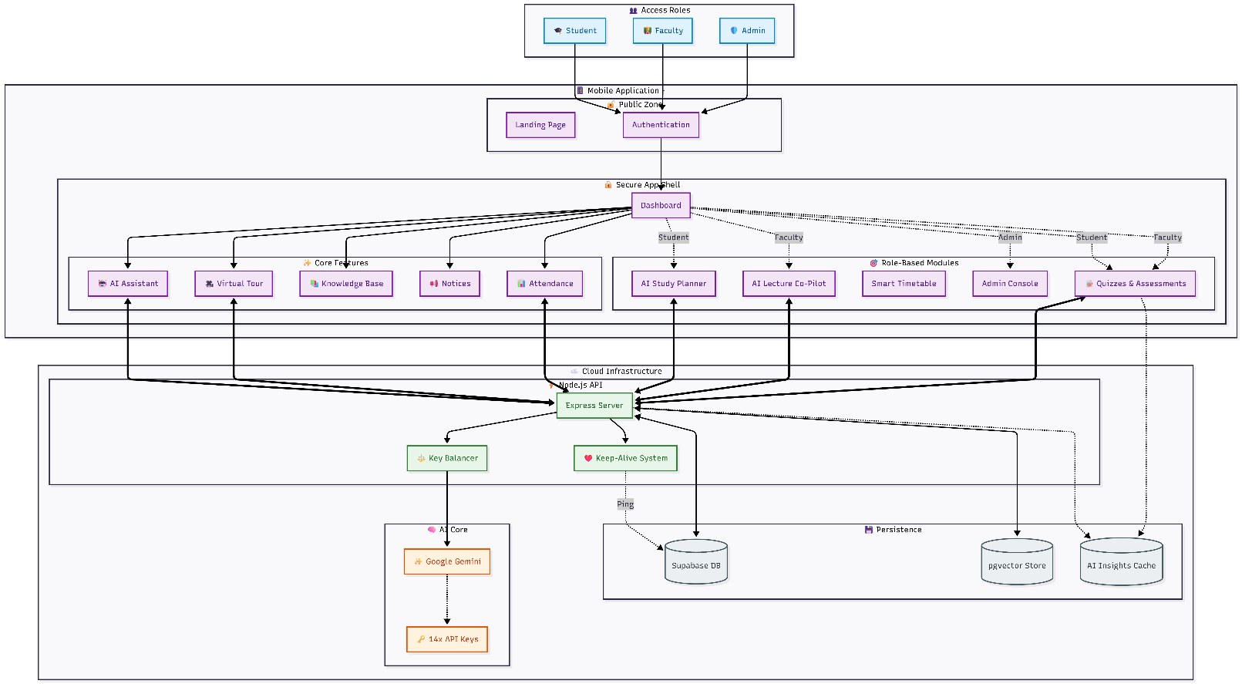
Figure 1: This architecture presents PMASS as a role-based, mobile-first academic platform where Students, Faculty, and Admins access a secure Flutter application backed by a Node.js API layer. Core and role-specific features route requests through an Express server that enforces authentication, load-balances across multiple Google Gemini API keys, and maintains reliability via a Keep-Alive system. Institutional data and knowledge are grounded using Supabase (PostgreSQL) and pgvector-based semantic retrieval, enabling context-aware, resilient AI assistance across the university ecosystem.
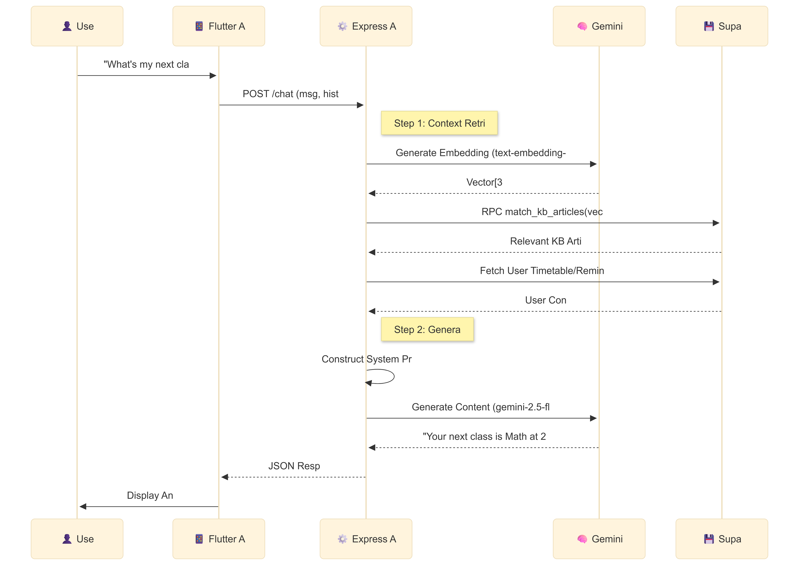
Figure 2 : This sequence diagram illustrates an AI campus assistant workflow. A user asks a question in the mobile app, which sends a chat request to the backend API. The server creates embeddings via Gemini, retrieves relevant knowledge base articles and the user’s timetable from Supabase, and constructs a system prompt. Gemini then generates a response, returned as JSON to the app, which displays the answer: the user’s next class and time.

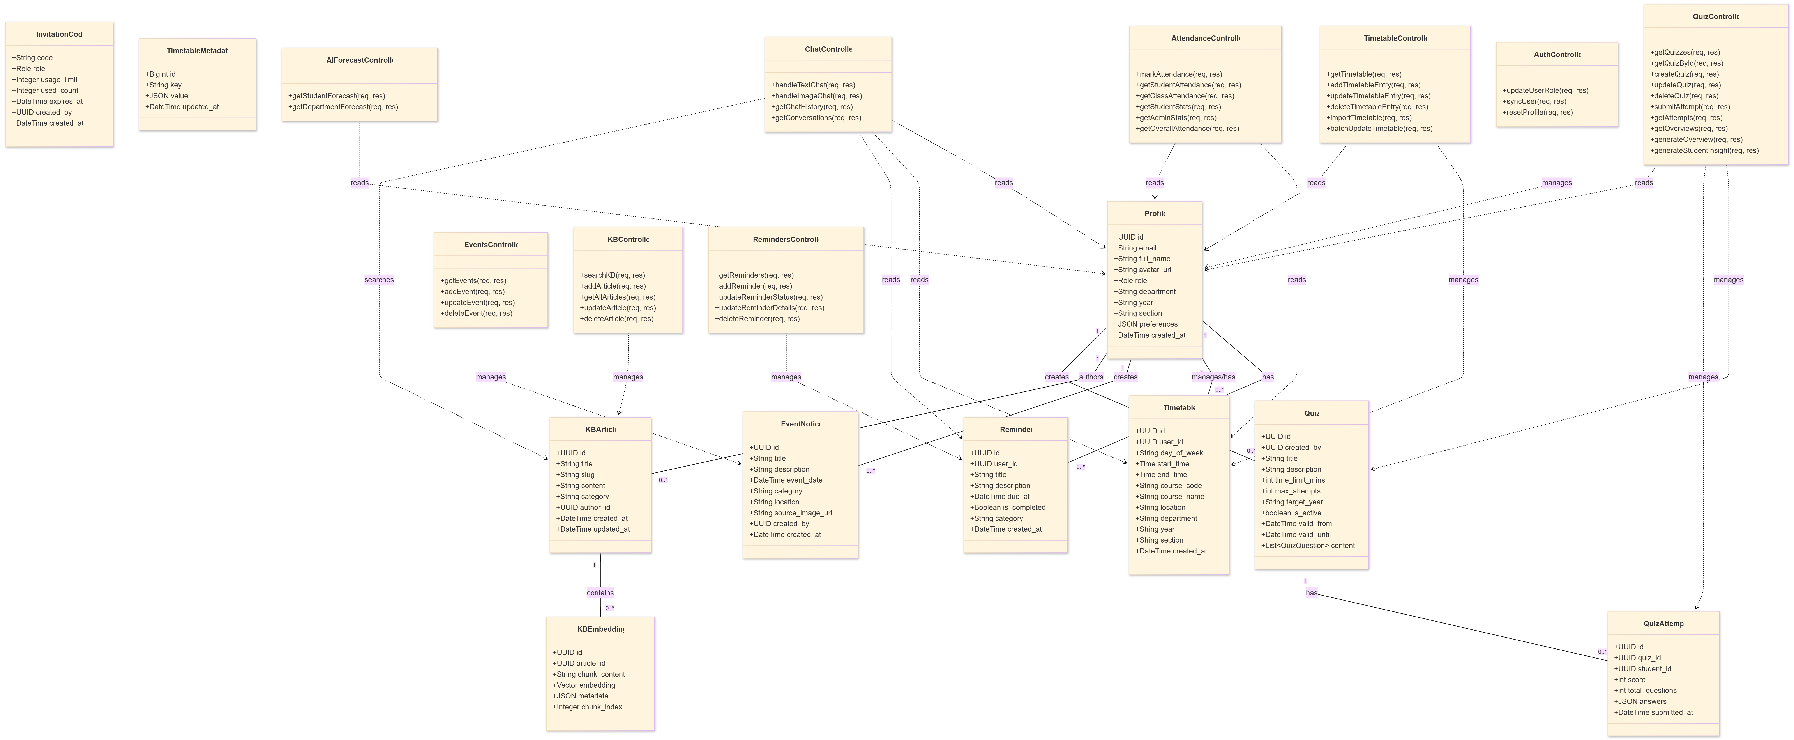
Figure 3: The diagram represents a class model for a campus assistant system. A User has login and logout functions and is associated one-to-one with a Profile containing personal and academic details. A User can send multiple ChatMessages, which store message content and timestamps. The Profile allows viewing or editing multiple Timetable entries, which store class schedule details and support updating time slots.

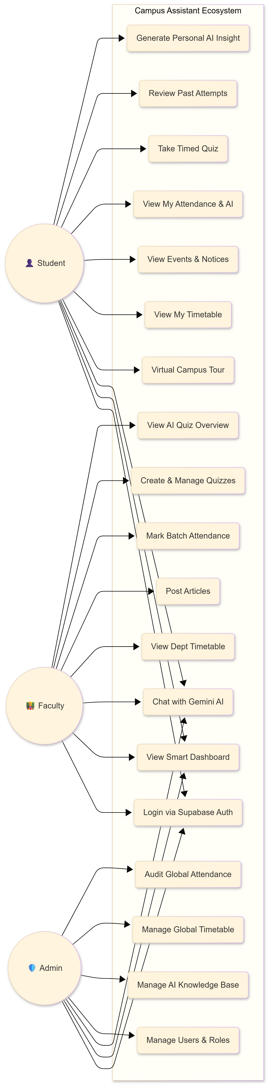
Figure 4: This diagram shows the Campus Assistant ecosystem with role-based access for Admin, Faculty, and Students. Admin manages the global timetable, AI knowledge base, and user roles. Faculty can view department timetables, dashboards, and post articles. Students access personal timetables, events, notices, virtual campus tours, and chat with Gemini AI. All users authenticate via Supabase. The system centralizes academic management, information sharing, and AI-powered assistance within a unified platform.

To enhance user engagement and spatial awareness, the landing interface incorporates a rotating 3D low-poly campus model rendered using model_viewer_plus, combined with a visually guided Rainbow Feature Carousel (ROYGCBIV). Such immersive, multimodal interfaces align with emerging design principles for AI-augmented educational systems [10], [15]. Performance optimization is achieved using the Impeller rendering engine, ensuring stable 60 FPS even with layered glassmorphic effects. Navigation and application flow are managed via GoRouter, while Riverpod maintains global state consistency, including the AuthContext, which functions as the client-side authority for authentication state and role awareness. To preserve UI consistency, the application enforces a portrait-only orientation, with an explicit exception for the Smart Timetable module, which dynamically enables landscape mode to support dense grid-based visualizations—an approach consistent with mobile usability guidelines for data-heavy views [33].

6.2 Logic Layer (Backend Orchestration)
The logic layer is developed using Node.js and Express (TypeScript) and serves as the central orchestration engine for all system interactions. This layer enforces security, aggregates multimodal context, and coordinates AI-assisted workflows. All protected endpoints are governed by a dual-middleware security model. The requireAuth middleware validates JWT/Bearer tokens issued by Supabase, while requireRole enforces server-side role-based access control (RBAC), preventing unauthorized execution of privileged operations such as academic schedule modification or administrative bulk actions [9], [17]. Complex requests—particularly conversational AI interactions—are handled by specialized controllers such as the Multimodal Chat Controller, which performs parallel context aggregation (e.g., user identity, timetable, reminders, and notices) before invoking the AI engine. This orchestration strategy reflects modern tool-augmented and agentic LLM interaction patterns [11], [18], [32].

6.3 Data & Intelligence Layer (Persistence and AI)
The data and intelligence layer integrates structured persistence with semantic AI capabilities to ground model outputs in institutional reality.
Structured academic data is stored in Supabase (PostgreSQL), while privileged backend operations are executed using a Service Role Key (SRK), allowing the server to bypass Row Level Security (RLS) when required for administrative or system-level tasks [9]. This design follows established security practices for multi-tenant educational platforms [17].
For semantic retrieval, PMASS employs pgvector, enabling similarity-based searches over institutional knowledge using vector embeddings. This approach supports Retrieval-Augmented Generation (RAG), significantly reducing hallucinations and improving factual grounding in domain-specific queries [6], [12], [28].
To address API rate-limit constraints common in free-tier deployments, the AiService manages seven independent Google Gemini API keys. Requests are distributed using key shuffling (load balancing), and failures are handled via automatic failover upon detection of HTTP 429 errors. This redundancy strategy enhances system robustness and aligns with best practices for reliable LLM-based services [5], [27], [34].

6.4 Operational Layer (Keep-Alive Infrastructure)
Given the system’s deployment on free-tier cloud platforms such as Render and Supabase, PMASS incorporates an explicit operational reliability layer to mitigate cold starts and service hibernation.
An external Heartbeat CRON job invokes the /api/health endpoint every 10 minutes, remaining safely below Render’s 15-minute inactivity threshold [8]. Upon invocation, the endpoint responds immediately with a 200 OK status while asynchronously triggering a silent background database query. This two-step strategy ensures both the application server and the database remain active, preventing Supabase’s 7-day pause policy from degrading system responsiveness.
Such proactive keep-alive mechanisms are consistent with recommended patterns for maintaining availability in serverless and resource-constrained cloud environments [8], [21].

7 Multimodal Interaction Framework
The Multimodal Interaction Framework in PMASS is designed to deliver a cohesive and intelligent user experience by routing heterogeneous data types through specialized processing pipelines. This design moves the system beyond a conventional text-based chatbot toward a structured “Prep Chef” architecture, where contextual signals are collected, filtered, and organized before invoking large language models (LLMs). Such an approach aligns with recent research advocating context-aware, human-centered AI systems in educational environments [1], [10], [16].

7.1 Multimodal Routing and Orchestration
PMASS implements modality-specific routing through dedicated backend endpoints, ensuring that each input type is processed

using the most appropriate computational and AI resources. This design reflects emerging best practices in multimodal AI systems, where task separation improves efficiency, interpretability, and reliability [2], [13], [15].
Text and Voice Interaction: Text-based queries and transcribed speech are processed through the handleTextChat pipeline, which emphasizes Context Fusion. Multiple contextual signals—including user identity, academic timetable, reminders, and institutional notices—are fetched in parallel using asynchronous aggregation mechanisms (Promise.all). These signals are injected into a consolidated system prompt, effectively grounding the LLM with institutional and temporal awareness. This approach is conceptually aligned with Retrieval-Augmented Generation (RAG) and knowledge-augmented LLM frameworks that enhance domain-specific reasoning and factual accuracy [6], [12], [28].
Image Analysis: Visual inputs are handled through a dedicated /image endpoint, where raw image data is captured using in-memory file handling and directly processed by the model’s multimodal vision-language capabilities. Unlike the text pipeline, this route minimizes contextual overhead to prioritize visual understanding. Such selective context injection reflects design recommendations in multimodal AI tutoring systems, particularly for STEM-oriented visual problem-solving tasks [2], [15].

7.2 Location-Aware Contextual Intelligence:
The framework extends beyond traditional conversational AI through a Virtual Tour AI Assistant, enabling location-aware interactions within a simulated campus environment.
Scene-Specific Prompting: As users navigate 360° panoramas, the assistant maintains awareness of the user’s virtual location and queries a Location Knowledge Base to provide environment-specific responses. This spatial grounding approach mirrors recent work on situated and embodied AI agents, where contextual awareness enhances relevance and user trust [19], [32].
Proactive Assistance and Robustness: The assistant proactively generates suggested questions based on the active scene, guiding exploratory learning and discovery. To ensure resilience, the system incorporates fallback mechanisms that allow continued operation using cached scene metadata during backend or network failures. Such robustness strategies are consistent with recommended practices for dependable AI-assisted systems deployed in real-world educational settings [8], [27].

7.3 Strategic AI Tool Integration
At the core of this multimodal framework is the centralized AiService, which manages interactions with Google Gemini models and orchestrates multiple API keys to support load balancing and automatic failover. This design directly addresses scalability and rate-limit challenges commonly associated with large-scale multimodal inference [5], [21], [31]. By ensuring high availability for text generation, image interpretation, and vector-based semantic retrieval, the framework maintains consistent performance even under peak usage conditions. This architectural choice aligns with contemporary research on reliable, distributed AI systems and foundation model deployment at scale [22], [23], [34].

8. System Features and Functionalities
PMASS integrates multiple intelligent modules designed to enhance academic productivity, spatial navigation, and administrative governance within educational institutions. The system architecture reflects recent advances in human-centered AI, multimodal interaction, and dependable AI system engineering [10], [16], [23], [34].

8.1 AI Lecture Co-Pilot
The AI Lecture Co-Pilot assists faculty in generating structured lesson plans and discovering verified academic resources such as peer-reviewed articles and instructional videos. The design follows retrieval-augmented and knowledge-grounded generation paradigms to mitigate hallucinations and improve factual reliability [6], [12], [28]. Exportable PDF outputs support academic documentation workflows and long-term reuse, aligning with AI-assisted knowledge work practices in professional environments [33], [35]. The feature positions the AI as a collaborative pedagogical assistant rather than a replacement for human educators, consistent with recent educational AI frameworks [1], [10], [36].

8.2 Virtual Tour Assistant
The Virtual Tour Assistant functions as a context-aware conversational agent embedded within a 3D campus tour environment. By maintaining awareness of the user’s spatial context, the assistant provides scene-specific information, improving engagement and situational relevance. This approach draws on research in situated AI agents and embodied interaction, where grounding AI responses in spatial environments improves user trust and comprehension [19], [32], [37]. Proactive suggestion generation supports exploratory learning and aligns with established human–AI interaction design principles emphasizing guidance and discoverability [16], [38].

8.3 Smart Scheduling
The Smart Scheduling module delivers a dynamic academic timetable with real-time updates, supporting bulk CSV/XLSX imports and professional PDF exports. Its architecture follows scalable, data-intensive system design principles suitable for cloud-native educational platforms [22], [25]. By integrating scheduling data into AI-driven interactions, the module enables context-aware personalization, which has been shown to significantly improve task efficiency and user satisfaction in intelligent systems [6], [27], [39].

8.4 User Management
Administrative governance is handled through an advanced User Management module featuring an elevated “God Mode” for role promotion, bulk user migration, and policy enforcement. Safety locks prevent accidental self-deletion or privilege misuse, addressing governance and accountability challenges frequently cited in large-scale AI deployments within institutions [17], [24], [34]. The system aligns with secure role-based access control, service-role architectures, and reliability engineering practices for AI-backed platforms [9], [21], [40].

9 System Features and Functionalities
The Proactive Multimodal Academic Support System (PMASS), also
referred to as the Campus Assistant, integrates a suite of intelligent, role-based features to centralise and enhance university operations within a secure digital ecosystem. The system design aligns with established principles of human-centred interaction, AI-assisted learning, and risk-aware system governance [35], [36], [40].

9.1 AI Lecture Co-Pilot (Faculty Tool)
The AI Lecture Co-Pilot is a faculty-centric module designed to automate pedagogical preparation while preserving instructional flexibility and academic autonomy. It enables educators to generate structured lecture outlines with clearly defined learning objectives and logical topic flows, thereby supporting cognitive load management and instructional clarity in accordance with human-centered design principles [35], [36]. The system further enhances adaptability through tone-selectable content modes—Formal, Engaging, and Storytelling—allowing instructors to tailor AI-generated material to diverse classroom dynamics and learner engagement strategies [36]. In addition, a verified resource discovery mechanism automatically curates relevant academic articles and educational videos, reflecting proactive information exploration approaches in conversational AI systems [38]. To ensure professional dissemination, lecture plans can be exported as well-formatted PDFs with clickable references, reinforcing usability, consistency, and structured knowledge delivery [35].

9.2 Virtual Tour AI Assistant
The Virtual Tour module provides an immersive 360° campus navigation experience augmented by a context-aware conversational assistant. The assistant dynamically adapts its responses based on the user’s spatial position within the digital campus model, aligning with augmented reality and spatial interaction paradigms in human–computer interaction research [37]. Through its integrated location knowledge base, users can retrieve building-specific information such as laboratory facilities, department offices, or operational hours, thereby enhancing situational awareness and navigational efficiency [37]. The system also incorporates scene-specific prompting, proactively suggesting context-relevant questions to guide exploration in line with proactive conversational agent design principles [38]. Furthermore, offline robustness is achieved through cached scene metadata, enabling partial functionality during connectivity disruptions and supporting resilience in distributed digital environments [40].

9.3 Smart Scheduling Engine
The Smart Scheduling Engine manages complex academic timetables through a real-time, interactive interface combined with scalable administrative controls. It integrates intelligent collision resolution through swap logic, ensuring database integrity while preserving user intent during timetable conflicts—consistent with interactive system design frameworks for visual data manipulation [39]. The engine supports bulk semester-wide schedule imports via CSV or XLSX files, employing transactional batch processing to prevent duplication and maintain structural consistency within institutional databases [40]. For administrative transparency and offline accessibility, department-level timetables can be exported as standardized professional PDFs [35]. Additionally, adaptive orientation switching to landscape mode for timetable visualization enhances grid readability and analytical clarity, aligning with principles of effective visual interaction design [39].

9.4 User Management and “God Mode”
Administrative governance is centralized within a high-privilege “God Mode” dashboard secured through backend service-level authentication mechanisms. Role promotion is managed through a dynamic, database-backed invitation system that replaces static credentials, thereby reducing security vulnerabilities while enabling controlled elevation of privileges [40]. Administrators are equipped to perform bulk migrations, academic year transitions, and content moderation at scale, supporting institutional growth and governance efficiency [36], [40]. Built-in safety mechanisms prevent administrators from accidentally deleting or demoting their own accounts, reinforcing error prevention and system reliability principles in human-centered design [35]. Moreover, specialized deletion logic ensures that institutional knowledge assets remain preserved even when user accounts are removed, guaranteeing long-term academic continuity and governance stability [40].

9.4 Quiz Performance Insights
This feature enables faculty to create quizzes efficiently using AI-generated questions, manual input, or by importing questions through CSV files, offering flexibility in assessment design. Once quizzes are conducted, students receive immediate, AI-driven feedback highlighting specific areas where they lack understanding, rather than just scores. This helps them focus on targeted improvement. Simultaneously, faculty gain detailed insights into overall class performance, including commonly misunderstood topics and individual student weaknesses. The system analyzes response patterns to identify learning gaps and trends, allowing educators to adapt their teaching strategies accordingly. By combining automated quiz creation, instant feedback, and performance analytics, this feature supports continuous learning, improves concept clarity, and enhances the effectiveness of both teaching and assessment processes within the academic environment.

9.5Attendance Trend Analysis
Faculty can efficiently mark attendance for scheduled classes, while students can view their attendance both on the dashboard and in a detailed insights page. The detailed view (Figure 26: Attendance Insights & Schedule) provides a structured display of daily classes along with AI-powered analysis, including projected attendance trends, percentage forecasts, and personalized feedback. Visual graphs further help in understanding progress over time. Additionally, administrators have access to department-wise analytics, enabling them to monitor attendance patterns and make informed academic decisions.

10 Security Architecture and Access Control
The Security Architecture and Access Control framework of the Proactive Multimodal Academic Support System (PMASS) is implemented as a multi-layered defense model that integrates authentication, authorization, and database-level enforcement to ensure data integrity, governance, and regulatory alignment. The architecture reflects best practices in secure distributed system design and institutional AI governance, combining backend verification mechanisms with structured database controls [9], [22], [40].

10.1 Authentication Mechanism
The first layer of protection is implemented through the requireAuth middleware, which enforces strict identity verification for every API interaction. Each client request must include a valid JWT (JSON Web Token) or Bearer Token in the request header. The backend verifies this token using supabase.auth.getUser(token), ensuring cryptographic validation of user identity before any business logic is executed. If the token is invalid or absent, the request is immediately terminated with a 401 Unauthorized response, preventing unauthorized system traversal. This server-side authentication model aligns with modern cloud-based identity verification practices and secure data-intensive application design principles [9], [22]. By enforcing identity validation prior to AI or database interaction, the system also supports responsible AI governance frameworks that emphasize secure access to institutional systems [17], [40].

10.2 Authorization and Role-Based Access Control
Following identity verification, the requireRole middleware enforces structured Role-Based Access Control (RBAC) across three hierarchical tiers: Student, Faculty, and Admin. The system queries the profiles table to retrieve the authenticated user’s assigned role and compares it against permitted roles defined for each endpoint. If a mismatch occurs, the request is rejected with a 403 Forbidden response. This layered authorization mechanism ensures that sensitive endpoints—such as timetable editing, administrative dashboards, or user deletion—are accessible only to authorized roles. While the frontend AuthContext synchronizes UI visibility (e.g., hiding the Admin Panel from students), the authoritative validation always occurs server-side to prevent client-side manipulation. Such multi-tiered RBAC enforcement reflects distributed governance models in educational AI systems [10], aligns with trustworthy multi-agent and multi-role system principles [34], and supports risk mitigation strategies recommended in national AI governance frameworks [40].

10.3 Database Security and Row-Level Security (RLS)
At the persistence layer, PMASS employs Row-Level Security (RLS) policies to enforce fine-grained access controls directly within the Supabase (PostgreSQL) database. Standard users can access only their own records—such as personal reminders or chat histories—ensuring strict data isolation and privacy compliance [9]. For high-privilege administrative operations, the backend Node.js server is initialized with a Service Role Key (SRK). This key allows the server to bypass RLS selectively for legitimate institutional operations, such as comprehensive user data deletion or department-wide timetable management. Crucially, this bypass capability is restricted exclusively to the backend environment and is inaccessible to client applications. This separation between client-level RLS enforcement and backend-level privileged operations aligns with secure cloud architecture patterns [22], data governance standards in AI-enabled infrastructures [25], and institutional risk management frameworks [40]. It also ensures operational scalability while maintaining strict control boundaries.

10.4 Dynamic Invitation System and Governance Controls
To mitigate risks associated with static credentials, PMASS replaces environment-based secrets (e.g., ADMIN_SECRET) with a dynamic, database-driven Invitation System. Administrators generate single-use or bulk invitation codes through the Admin Dashboard, enabling controlled role elevation to Faculty or Admin status. This reduces credential leakage risks and enhances auditability. The administrative interface incorporates a Safety Lock mechanism, preventing administrators from deleting or demoting their own accounts. This design reflects human-centered error-prevention principles in interactive systems [35] and governance best practices in educational AI environments [17] Additionally, the system implements structured deletion logic to preserve institutional knowledge assets (e.g., wiki articles or academic notices) even if a contributing Faculty or Admin account is removed. This ensures long-term knowledge continuity and aligns with responsible AI lifecycle management practices [23], large-scale system governance principles [21], and national AI risk management recommendations [40].

11 Results
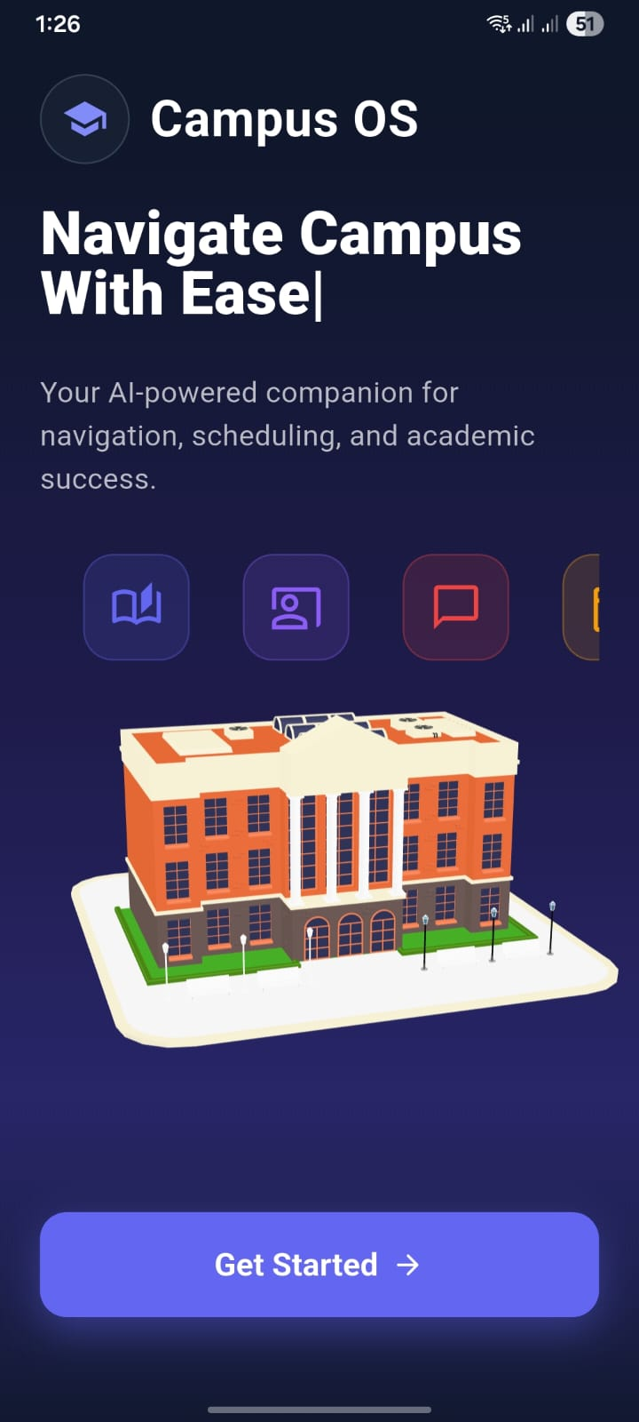

Figure 5: Landing Page (App Homepage)
The Campus OS landing page introduces the app as an AI-powered campus companion for navigation, scheduling, and academic support. A clear “Get Started” button enables users to quickly begin using the system.

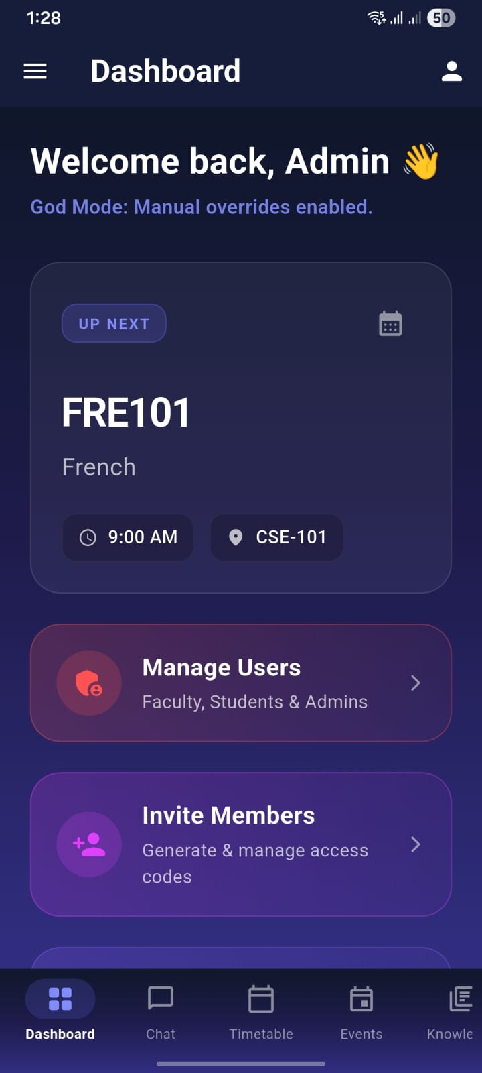

Figure 6: Admin Dashboard (God Mode Interface)
The Admin Dashboard provides high-privilege controls, displaying upcoming schedules and administrative tools such as user management and member invitations.
“God Mode” indicates enabled manual overrides, allowing administrators to perform critical system-level operations securely.
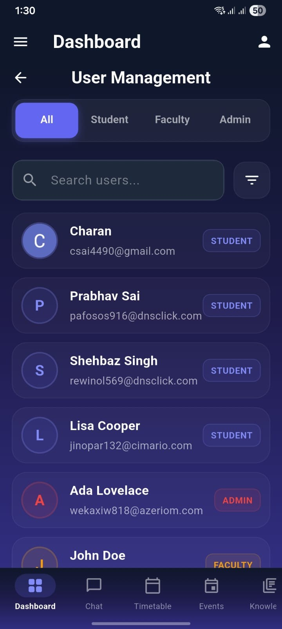

Figure 7: User Management Interface
The User Management screen enables administrators to view, search, and filter users by roles such as Student, Faculty, and Admin.
It provides centralized control for monitoring accounts and managing role-based access within the system.

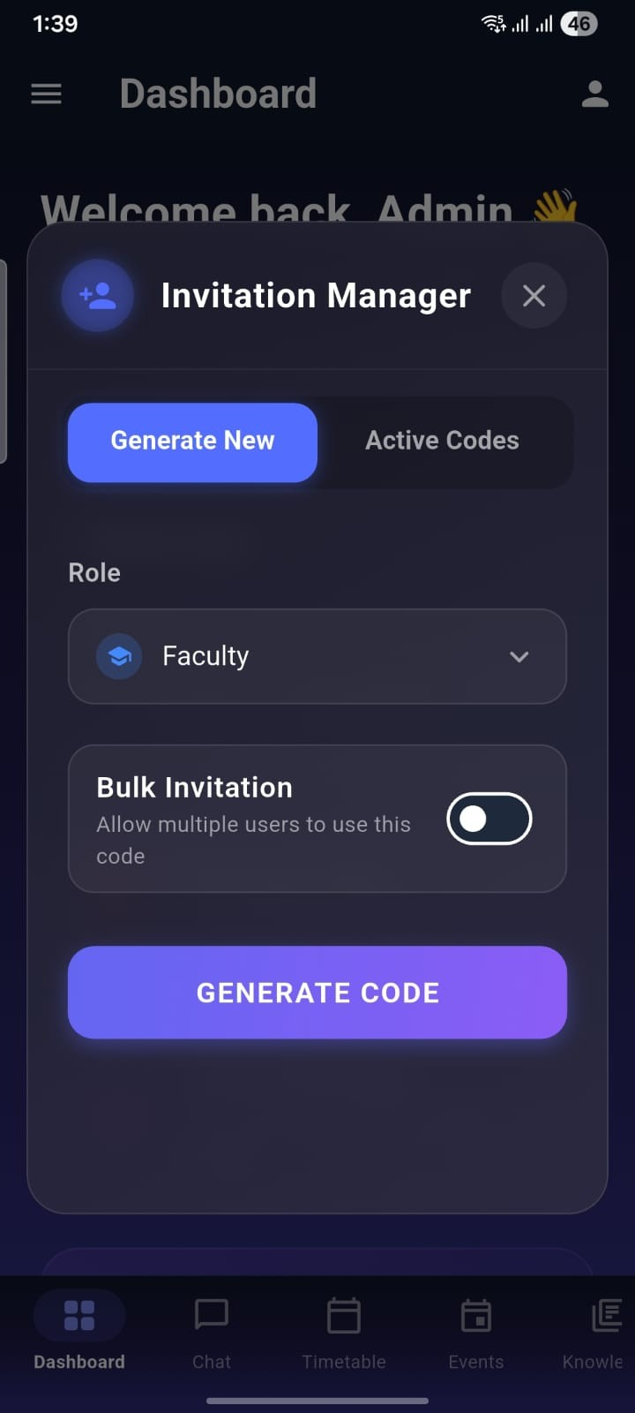

Figure 8: Invitation Manager Interface
The Invitation Manager allows administrators to generate secure access codes for role-based onboarding, such as Faculty or Admin accounts. It supports single-use or bulk invitations, enabling controlled user promotion and streamlined institutional access management.
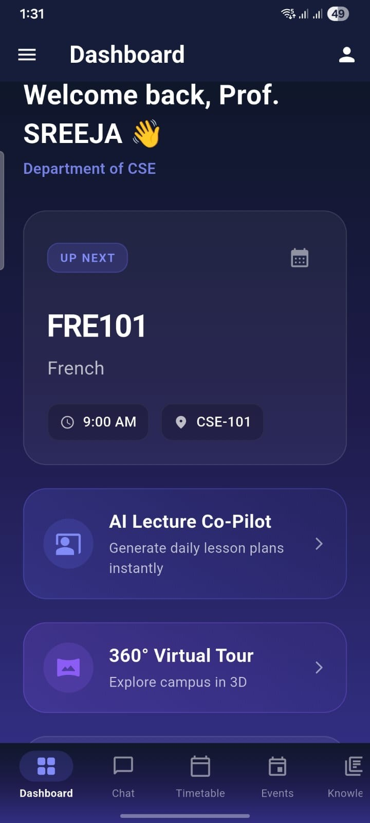

Figure 9: Faculty Dashboard Interface
The Faculty Dashboard provides personalized academic insights, including upcoming classes, department details, and quick access to teaching tools. It integrates features such as the AI Lecture Co-Pilot and 360° Virtual Tour to support instructional planning and campus navigation.
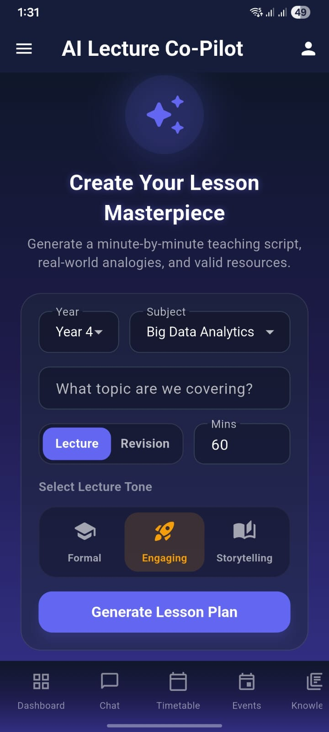

Figure 10: AI Lecture Co-Pilot Interface
The AI Lecture Co-Pilot enables faculty to generate structured lesson plans by selecting academic parameters such as year, subject, topic, duration, and lecture mode. It also allows tone customization (Formal, Engaging, Storytelling) to produce pedagogically aligned teaching scripts and resources.
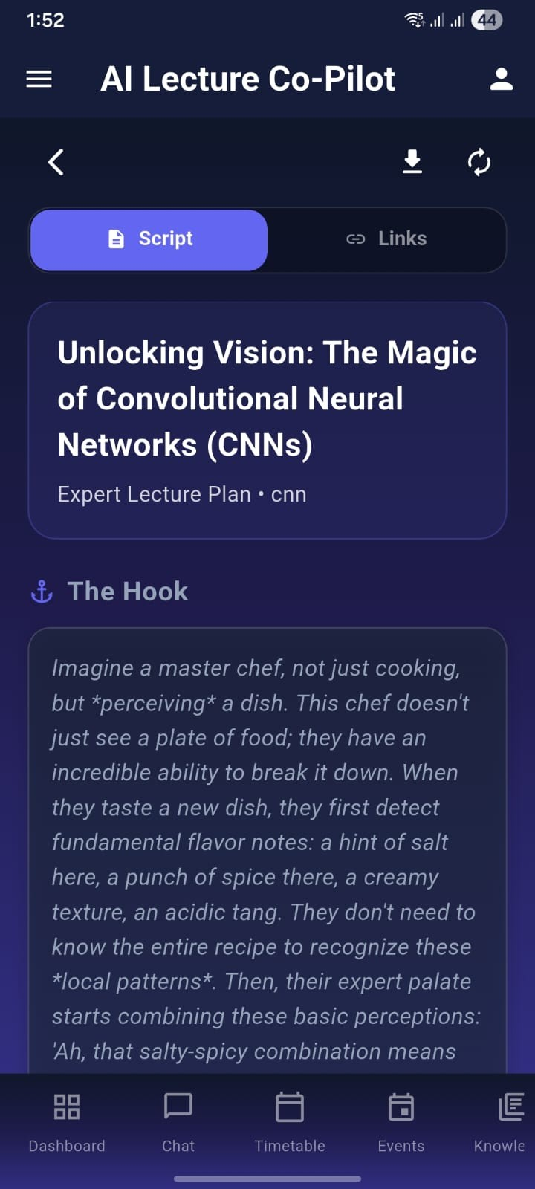

Figure 11: Generated Lecture Script View
This screen displays the AI-generated expert lecture script, including an engaging hook and structured content for the selected topic (CNNs). It allows faculty to review, download, or access supporting links for delivering a well-prepared session.

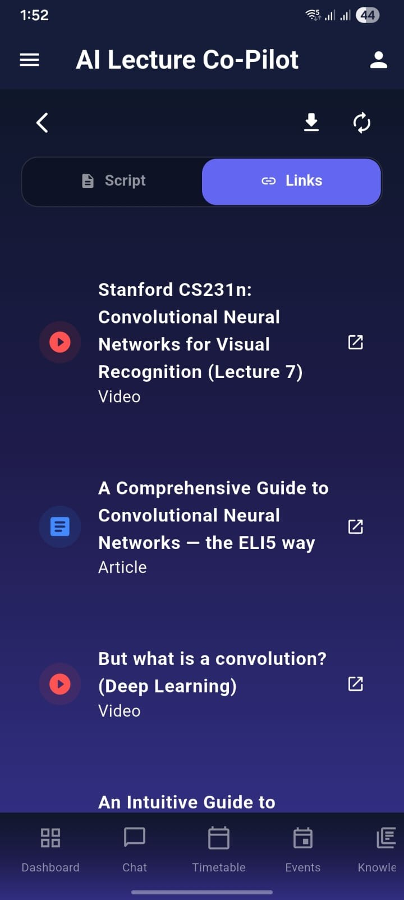

Figure12: Generated Lecture Links View
This screen displays curated supporting resources for the selected topic (CNNs), including recommended videos and articles. It allows faculty to quickly access high-quality external materials to enhance their lecture delivery. Users can open links in a new tab, download resources, or switch back to the script view for structured lecture content, ensuring a well-supported and comprehensive teaching session.

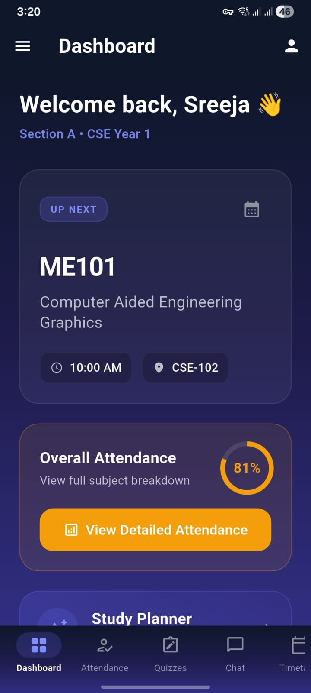

Figure 13: Student Dashboard View
This screen presents the personalized dashboard of the application, welcoming the user and displaying academic details such as section and year. It highlights the upcoming class with subject, time, and classroom information, along with an attendance overview and quick access to detailed analytics.It also provides access to key features including the AI-generated Study Planner, 360° Virtual Campus Tour, and pending tasks. A bottom navigation bar enables movement across modules like Dashboard, Chat, Timetable, Events, and Knowledge for efficient academic management.
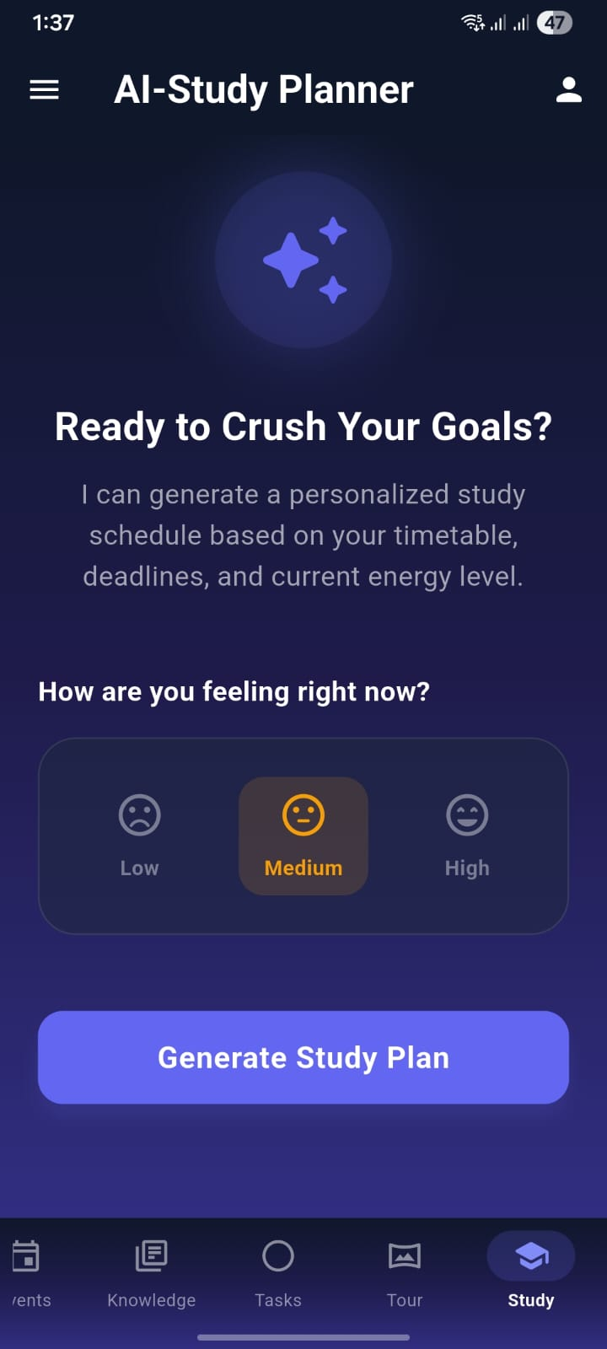

Figure 14: AI Study Planner View
This screen presents the AI-powered Study Planner feature, designed to generate a personalized study schedule based on the user’s timetable, deadlines, and current energy level. The interface
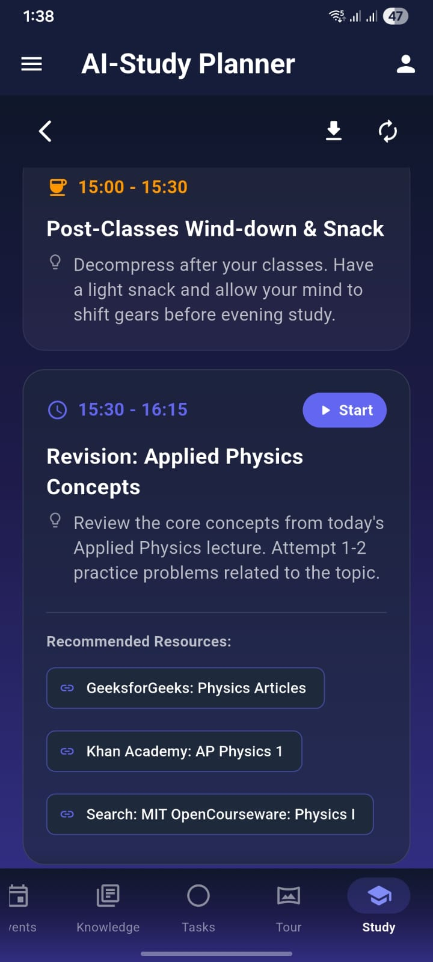

Figure 15: Generated Study Plan View
This screen displays the AI-generated personalized study schedule, structured into time-based activity blocks. It includes a balanced mix of relaxation and focused revision sessions tailored to the user’s selected energy level

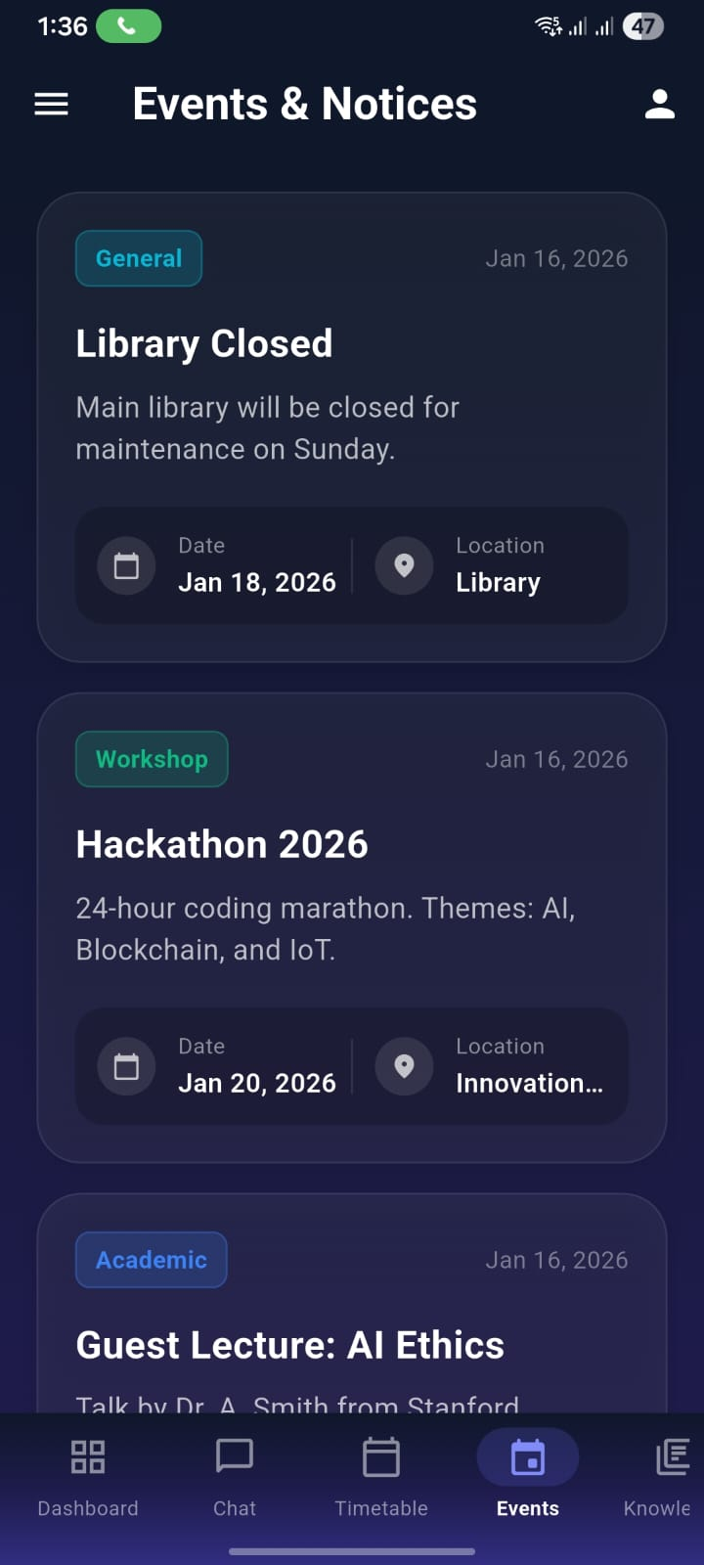

Figure 16: Events & Notices View
This screen displays the Events & Notices section, providing users with important campus announcements and upcoming activities. Each event card includes a category label (e.g., General, Workshop, Academic), event title, brief description, date, and location details.

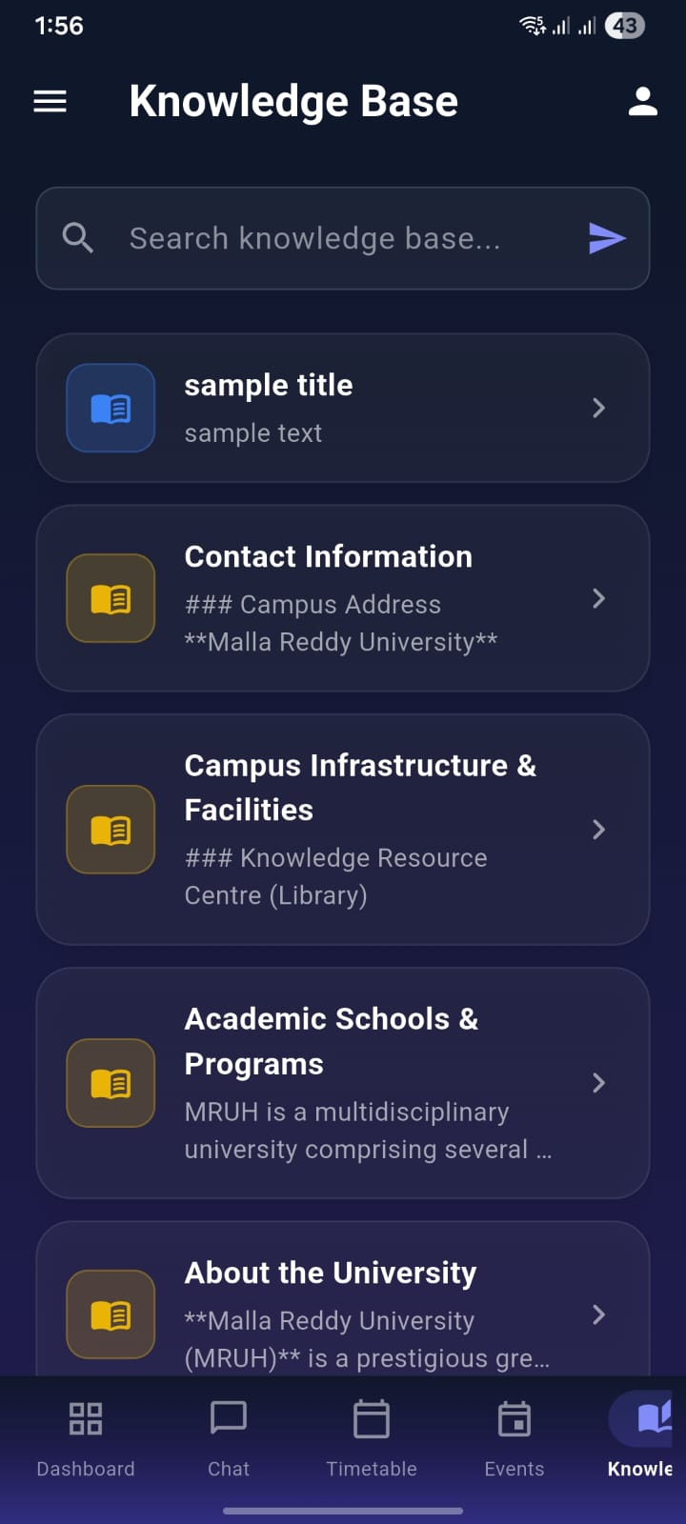

Figure 17: Knowledge Base View
This screen displays the Knowledge Base section, which provides structured and searchable institutional information for students. Users can utilize the search bar to quickly find relevant content. The section includes categorized entries such as Contact Information, Campus Infrastructure & Facilities, Academic Schools & Programs, and About the University.
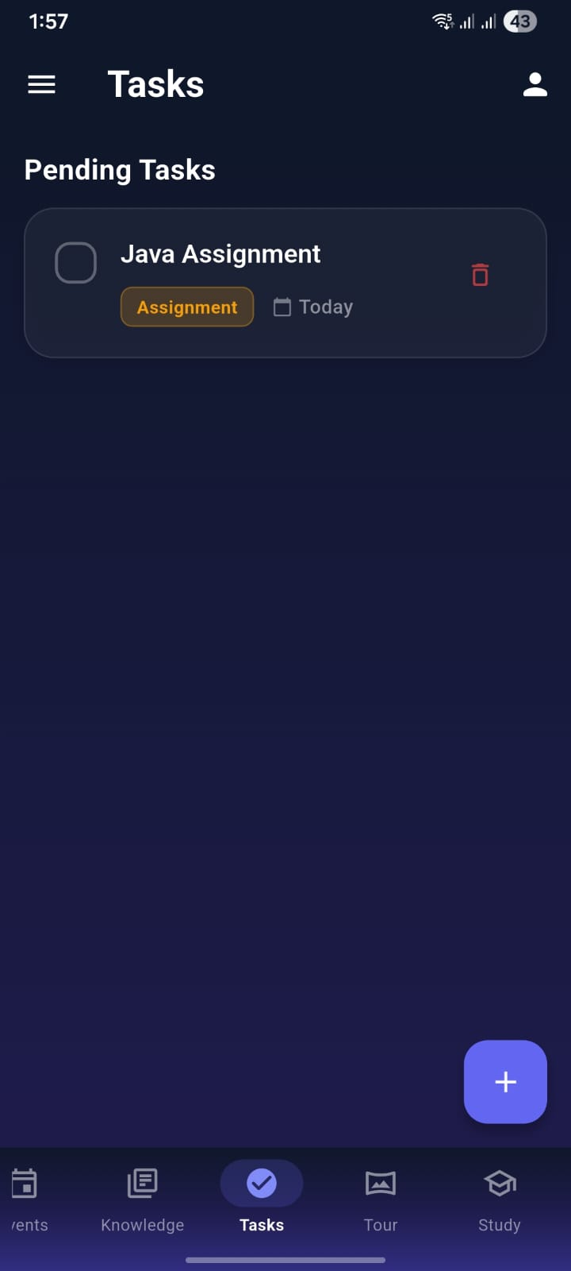

Figure 18: Tasks View
This screen displays the Tasks module, which helps users manage and track their pending academic activities. It shows a list of tasks with details such as task title, category (e.g., Assignment), and due date. Users can mark tasks as completed using the checkbox or delete them using the delete icon.
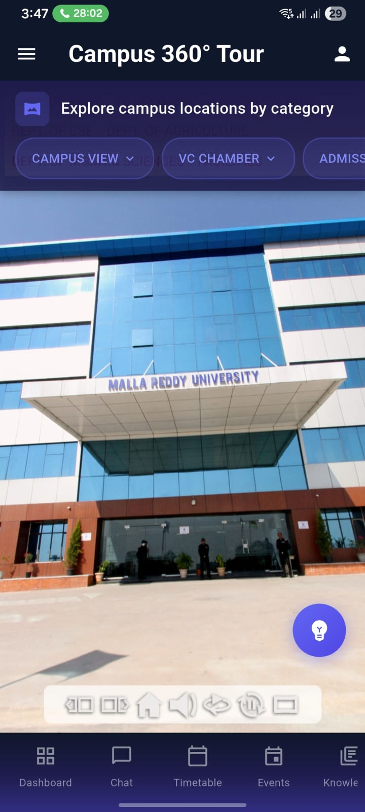

Figure 19: Campus 360° Tour View
This screen presents the Campus 360° Tour feature, enabling users to virtually explore university locations through an immersive panoramic view. Users can browse campus areas by category (e.g., Campus View, VC Chamber, Admissions) using the dropdown filters.

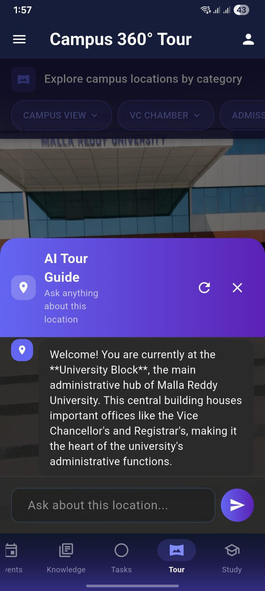

Figure 20: AI Tour Guide Interaction Screen
This screen shows the AI Tour Guide within the Campus 360° Tour, providing interactive information about the selected campus location. Users can ask questions about the University Block and navigate easily using the category filters and bottom menu.

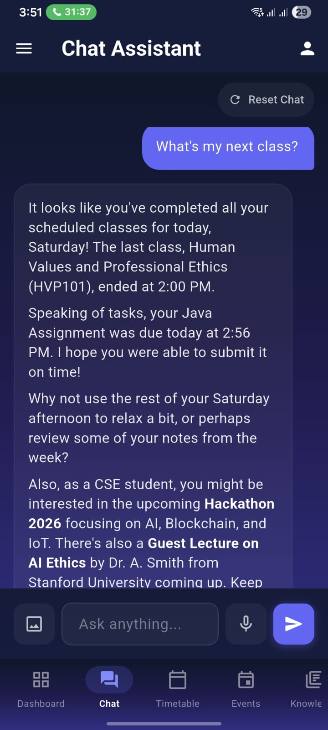

Figure 21: Chat Assistant Interface View
This screen shows the Chat Assistant feature that allows users to ask questions about schedules, exams, and campus notices through an interactive chat interface. It also provides quick-action buttons, voice input, and navigation tabs for easy access to other sections.

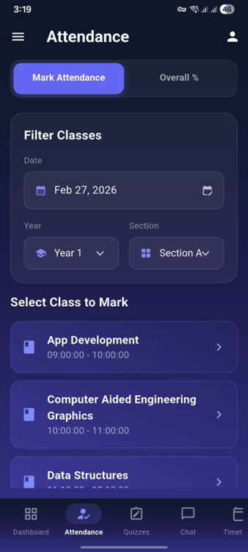

Figure 22:Attendance Management
This screen displays the Attendance Management module, enabling users to efficiently mark and monitor attendance with filtering options based on date, year, and section for easy class selection. Users can select specific subjects and mark attendance for scheduled time slots, while also accessing overall attendance insights, all within an intuitive interface that supports seamless navigation to other modules like Dashboard, Quizzes.

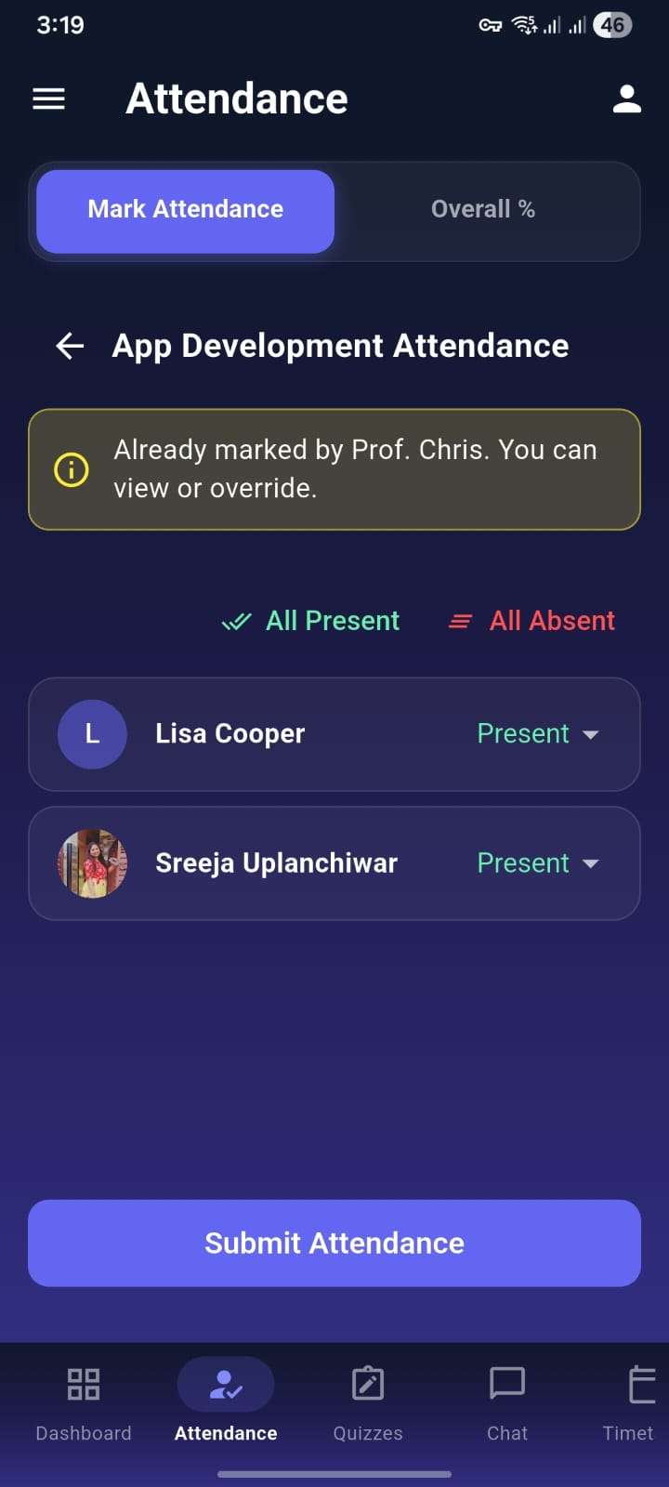
Figure 23: Attendance Marking Interface
This screen displays the attendance marking interface for a specific class, allowing faculty to view and update student attendance efficiently. It shows a notification if attendance has already been recorded, with options to override if needed. Faculty can quickly mark students as present or absent individually or use bulk actions, and finalize the process using the submit button, ensuring accurate and streamlined attendance management.

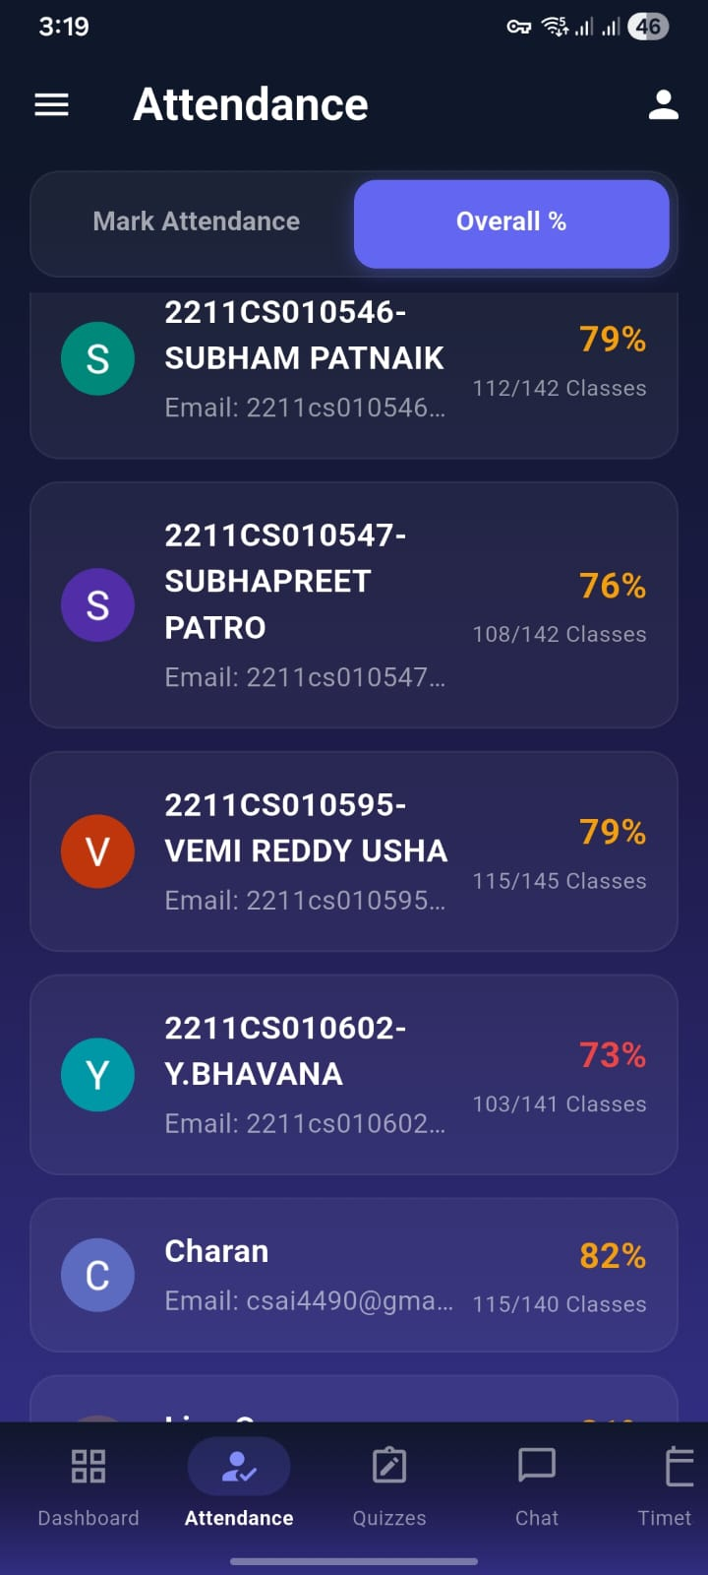
Figure 24:Student Attendance Dashboard Overview
This page displays a structured view of students’ attendance records, allowing users to easily monitor overall percentages. Each student entry includes an ID, name, partial email, number of attended classes, and total classes, with attendance percentages highlighted for quick comparison. The interface features a toggle between marking attendance and viewing overall statistics, along with a bottom navigation bar for accessing dashboard, quizzes, chat, and timetable sections, making it a centralized academic tracking tool.
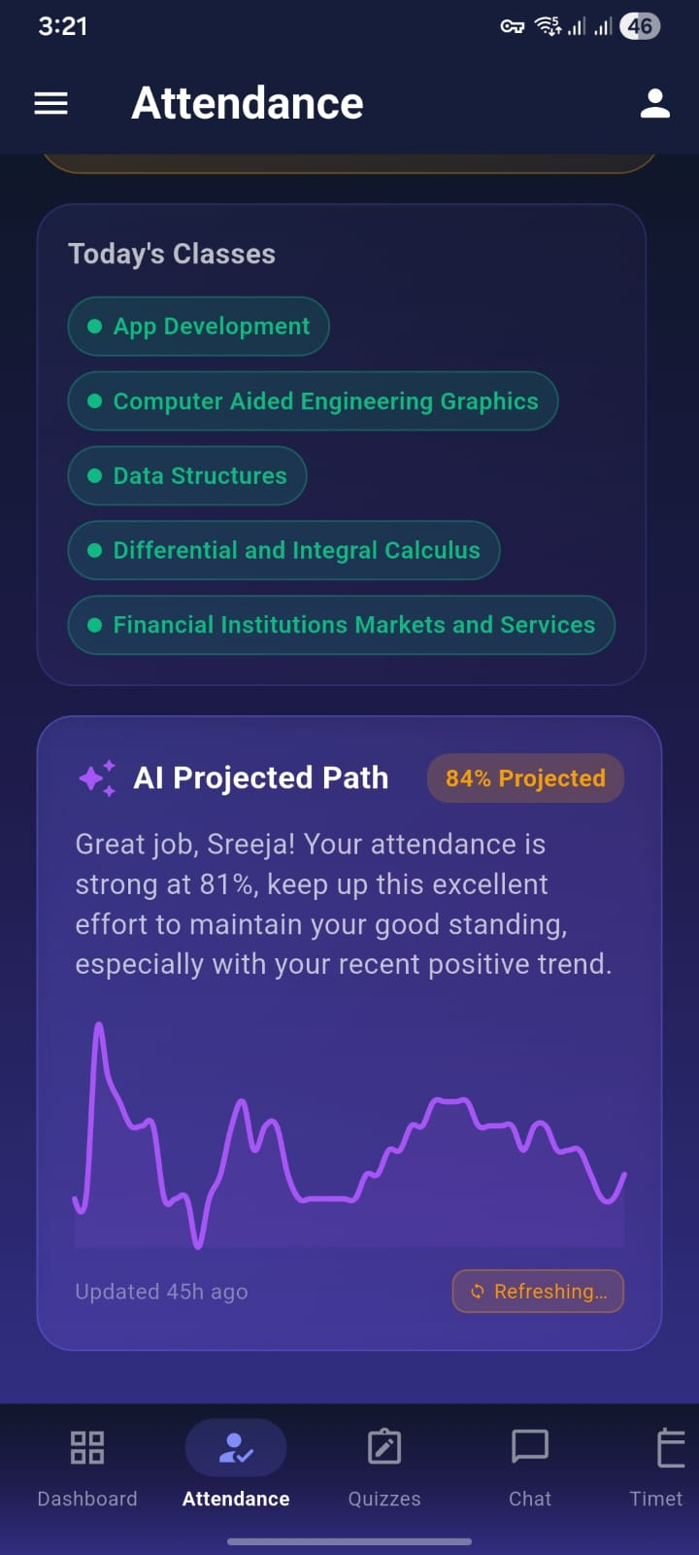

Figure 25:Attendance Insights & Schedule
This page provides a clear overview of today’s scheduled classes along with an AI-powered attendance analysis. It lists subjects for the day in an organized format and highlights an “AI Projected Path” that evaluates current attendance trends and predicts future performance. The section includes personalized feedback, percentage projections, and a visual graph, helping users understand progress and stay motivated while managing their academic attendance effectively.
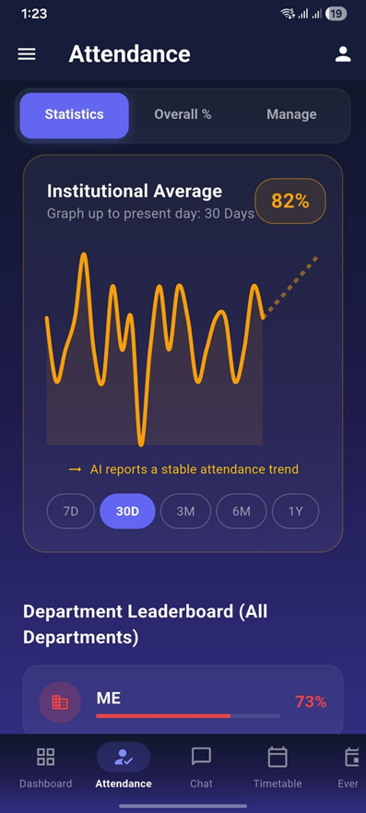

Figure 26: Admin Attendance Dashboard Overview
This admin dashboard provides a clear overview of institutional attendance performance. It displays an 82% average attendance over the last 30 days using a line graph that highlights daily variations and a stable trend identified by AI. Admins can switch between different time ranges such as 7 days, 3 months, or 1 year for deeper analysis. A department leaderboard compares attendance across departments, helping identify lower-performing areas like ME at 73%. The bottom navigation bar offers quick access to key sections including Dashboard, Attendance, Chat, Timetable, and Events, making it a centralized and efficient tool for monitoring and managing attendance.

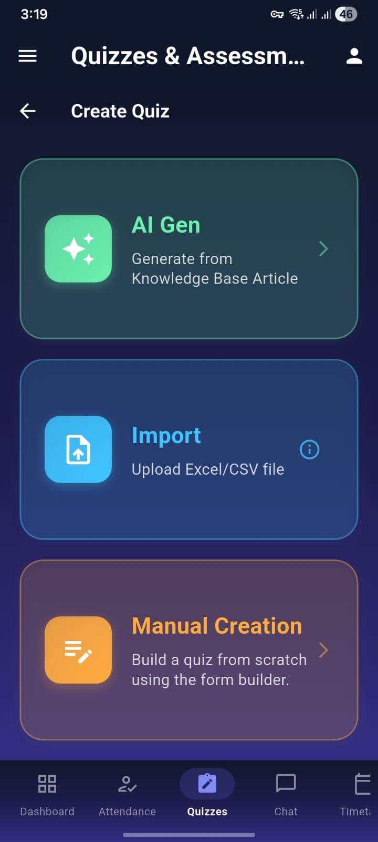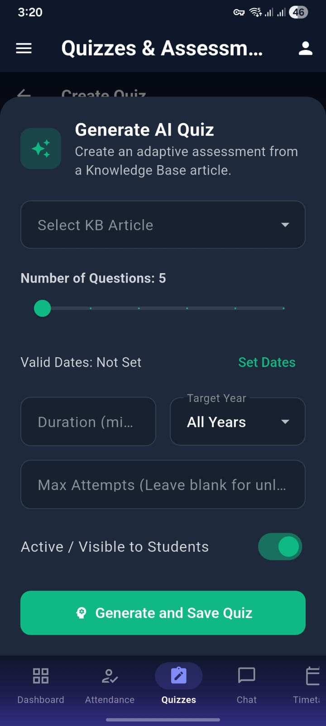

Figure 27: Smart Quiz Creation Options
This page enables users to create quizzes through multiple flexible methods. It offers an AI-powered generation feature that creates quizzes from a knowledge base, an import option to upload questions via Excel or CSV files, and a manual creation tool for building quizzes from scratch. The clean layout and intuitive options make quiz creation quick, efficient, and adaptable to different user needs.
Figure 28: AI Quiz Generator Setup
This page allows users to configure and generate AI-powered quizzes from a selected knowledge base article. It includes options to choose the article, set the number of questions using a slider, define valid dates, duration, target year, and maximum attempts. Users can also toggle quiz visibility for students. The interface is designed for quick customization, ending with a “Generate and Save Quiz” button for seamless quiz creation.

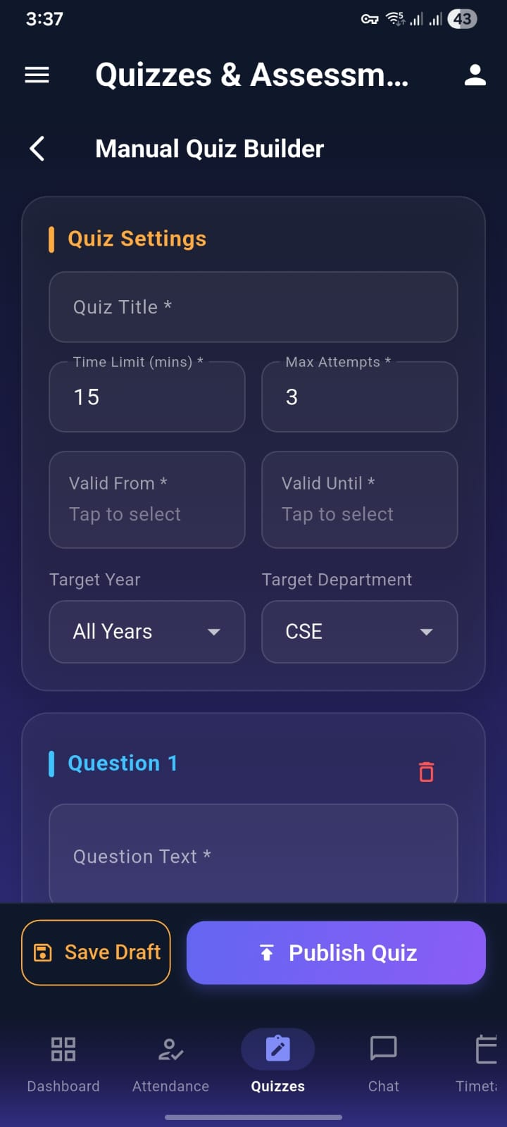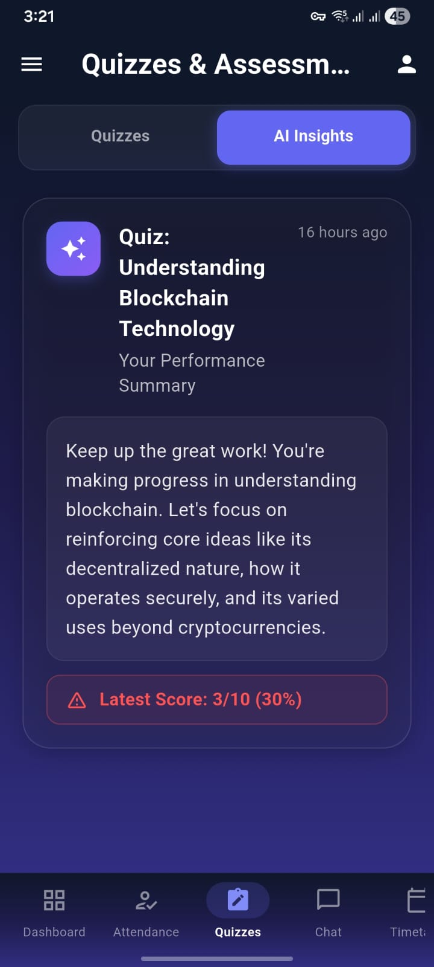

Figure 29:Manual Quiz Builder Interface
This page provides a detailed interface for creating quizzes manually with full control over settings and content. Users can define quiz details such as title, time limit, attempts, validity dates, target year, and department. It also allows adding and editing questions individually. With options to save as a draft or publish instantly, the page ensures flexibility and efficient quiz management.

Figure 30: Blockchain Learning Progress Overview
The screen shows an AI-generated performance summary for a quiz on blockchain technology, highlighting the user’s ongoing learning journey. It encourages continued effort while suggesting a focus on key concepts such as decentralization, security mechanisms, and real-world applications beyond cryptocurrencies. Despite a relatively low recent score of 3/10 (30%), the feedback remains positive and constructive, aiming to guide improvement and deepen understanding through targeted reinforcement of core ideas.



Figure 31 : Course Timetable Screen
This screen displays the Course Timetable for CSE (Year 1, Section A), showing subject schedules from Monday to Saturday with time slots. It includes clearly marked short and lunch breaks, helping students easily track their daily classes.

12 Conclusion
The Proactive Multimodal Academic Support System (PMASS) demonstrates that a scalable, intelligent, and secure university companion can be architected using cloud-native infrastructure while operating within free-tier deployment constraints. Through multi-key API load balancing, structured context-fusion pipelines, and backend-enforced security controls, the system successfully transforms general-purpose multimodal foundation models into a context-aware institutional assistant [2], [13], [14], [21]. By mitigating rate-limit bottlenecks using distributed key orchestration strategies aligned with quota management practices [5], and addressing serverless cold-start latency through a lightweight heartbeat CRON mechanism [8], the platform ensures continuous availability for academic stakeholders.
The integration of the “Prep Chef” context assembly logic—which aggregates timetable data, reminders, notices, and user identity prior to LLM invocation—implements a practical retrieval-augmented personalization strategy consistent with knowledge-grounded AI architectures [6], [12], [28]. This design reduces hallucination risk and enhances response relevance within institutional domains. Moreover, the enforcement of Role-Based Access Control (RBAC), combined with Row-Level Security (RLS) and
backend Service Role Key (SRK) safeguards, aligns with secure data-intensive application principles and national AI risk governance frameworks [9], [22], [40]. The inclusion of human-centered safeguards, such as administrative safety locks and controlled role

elevation, further strengthens system reliability and accountability [35], [17].
Collectively, PMASS validates that multimodal AI systems can be responsibly embedded within academic ecosystems when supported by structured governance, distributed AI infrastructure, and usability-centered interface design [23], [34].

References
- Sherif Abdelhamid, James Bangura, Shahryar Shah, et al. 2025. Advisely: AI-Powered Academic Advising Using Large Language Models (LLMs). In Conference Proceedings, New Perspectives in Science Education 2025.
- Google DeepMind. 2023. Gemini: A Family of Highly Capable Multimodal Models. In Proceedings of the 2023 Conference on Neural Information Processing Systems (NeurIPS 2023).
- Josh Achiam, Steven Adler, Sandhini Agarwal, et al. 2023. GPT-4 Technical Report. In Proceedings of the 2023 Conference on Neural Information Processing Systems (NeurIPS 2023).
- Supabase Inc. 2024. pgvector: Open-Source Vector Similarity Search for Postgres. In Supabase Technical Documentation and Developer Reports 2024.
- Google AI Platform Team. 2024. Generative AI API Rate Limits and Quota Management. In Google Cloud Technical Documentation 2024.
- Patrick Lewis, Ethan Perez, Aleksandra Piktus, et al. 2020 (updated implementations 2023–2024). Retrieval-Augmented Generation for Knowledge-Intensive NLP Tasks. In Advances in Neural Information Processing Systems.
- J. Johnson, M. Douze, and H. Jégou. 2017 (updated 2023). Billion-Scale Similarity Search with GPUs. In IEEE Transactions on Big Data.
- Render Engineering Team. 2024. Managing Cold Starts in Serverless Deployments. In Render Technical Documentation 2024.
- Supabase Inc. 2024. Row Level Security and Service Role Key Architecture. In Supabase Security Documentation 2024.
- Diyi Yang, Besmira Nushi, Ece Kamar, et al. 2023. Human-Centered AI in Education: Principles and Practices. In ACM Conference on Fairness, Accountability, and Transparency (FAccT 2023).
- Shunyu Yao, Jeffrey Zhao, Dian Yu, et al. 2023. ReAct: Synergizing Reasoning and Acting in Language Models. In International Conference on Learning Representations (ICLR 2023).
- Tianyi Zhang, Varsha Kishore, Felix Wu, et al. 2023. Knowledge-Augmented Language Models for Domain-Specific QA. In ACL 2023.
- OpenAI. 2024. GPT-4o: Multimodal Foundation Model Technical Overview. In OpenAI Technical Report 2024.
- Gemini Team. 2024. Gemini 1.5: Scaling Multimodal Reasoning with Long Context Windows. In Google DeepMind Technical Report 2024.
- Li et al. 2023. Multimodal AI Tutors: Integrating Vision and Language for STEM Education. In IEEE Transactions on Learning Technologies.
- Amershi et al. 2023. Guidelines for Human-AI Interaction. In CHI Conference Proceedings 2023.Ye He and Bryant Hutson. 2017. Assessment for Faculty Advising: Beyond the Service Component. NACADA Journal 37 (01 2017), 66–75. doi:10.12930/ NACADA-16-028
- Madaio et al. 2024. Human-Centered AI Governance in Educational Institutions. In ACM Conference on AI, Ethics, and Society 2024.
- Qin et al. 2023. Tool Learning with Foundation Models. In NeurIPS 2023 Workshops.
- Park et al. 2023. Generative Agents: Interactive Simulacra of Human Behavior. In ACM UIST 2023
- Hong et al. 2024. Multi-Agent LLM Systems: A Survey. In arXiv preprint 2024.
- Dean et al. 2023. Large-Scale Distributed Systems for AI Workloads. In Communications of the ACM.
- Kleppmann. 2023. Designing Data-Intensive Applications (Updated Cloud Patterns Edition). O’Reilly Media.
- Bommasani et al. 2021 (updated 2023). On the Opportunities and Risks of Foundation Models. Stanford CRFM Report.
- OpenAI. 2023. GPT-4 System Card. OpenAI Safety Report.
- Zaharia et al. 2023. Databricks Lakehouse Architecture for AI Workloads. VLDB 2023.
- Wang et al. 2023. Self-Consistency Improves Chain-of-Thought Reasoning in Language Models. ICLR 2023.
- Li et al. 2024. Reliable LLM Systems: Evaluation and Robustness Challenges. arXiv preprint 2024.
- Chen et al. 2023. Evaluating Retrieval-Augmented Generation Systems: Metrics and Benchmarks. EMNLP 2023.
- Touvron et al. 2023. LLaMA 2: Open Foundation and Fine-Tuned Chat Models. Meta AI Technical Report.
- Wei et al. 2022 (updated 2023). Chain-of-Thought Prompting Elicits Reasoning in Large Language Models. NeurIPS 2022.
- Rajbhandari et al. 2023. DeepSpeed: System Optimizations for Large-Scale Model Inference. Microsoft Research.
- Zhou et al. 2023. Large Language Models as Autonomous Agents: A Survey. arXiv 2023.
- Dang et al. 2023. Designing AI-Augmented Interfaces for Knowledge Work. CHI 2023.
- Wang et al. 2024. Trustworthy Multi-Agent LLM Systems: Challenges and Design Principles. arXiv 2024.
- D. A. Norman, The Design of Everyday Things, Revised and Expanded ed. Cambridge, MA, USA: MIT Press, 2013, updated conceptual and applied perspectives, 2023.
- R. Luckin, W. Holmes, M. Griffiths, and L. B. Forcier, Intelligence Unleashed: An Argument for AI in Education. London, U.K.: Pearson Education, 2016, with updated analytical perspectives on AI-supported learning systems and educational transformation, 2023.
- M. Billinghurst, A. Clark, and G. Lee, “A Survey of Augmented Reality,” Foundations and Trends® in Human–Computer Interaction, vol. 8, no. 2–3, pp. 73–272, 2015, with updated applications and interaction paradigms reported in subsequent literature, 2023.
- W. Xu, J. Yang, L. Findlater, and M. Xiong, “Designing Proactive Conversational Agents for Information Exploration,” in Proceedings of the 2023 CHI Conference on Human Factors in Computing Systems (CHI ’23), Hamburg, Germany, 2023, pp. 1–15.
- J. Heer and B. Shneiderman, “Interactive Dynamics for Visual Analysis,” Communications of the ACM, vol. 55, no. 4, pp. 45–54, 2012, revisited with updated relevance to modern interactive analytics and AI-assisted visualization systems, 2023.
- National Institute of Standards and Technology (NIST), Artificial Intelligence Risk Management Framework (AI RMF 1.0), NIST Special Publication, Gaithersburg, MD, USA, 2023.
- Sandhu, R., Coyne, E., Feinstein, H., & Youman, C. 1996 (revisited in modern cloud systems literature 2023). Role-Based Access Control Models. IEEE Computer.
- OWASP Foundation. 2023. OWASP Top 10: The Ten Most Critical Web Application Security Risks.
- Stallings, W., & Brown, L. 2018 (updated cloud security perspectives 2023). Computer Security: Principles and Practice. Pearson.
- ENISA. 2023. Securing Machine Learning Algorithms and Systems. European Union Agency for Cybersecurity Report.
- Karthik Sreedhar, Alice Cai, Jenny Ma, Jeffrey V Nickerson, and Lydia B Chilton. ISO/IEC 27001:2022 (implementation updates 2023). Information Security Management Systems (ISMS) Requirements. International Organization for Standardization.

